**Commercial Building Energy Consumption modeling**

1. **Problem Statement:**

Energy Consumption data is obtained for 78 buildings and the goal is to monitor and reduce energy consumption so that the buildings can be made more efficient. Data science skills have to be applied and models have to be built for prediction, classification and clustering. The goal for this report is to deploy these models as a web service using Azure Machine learning studio and build a user interface to invoke the web service.

1. **Build Web Services:**
2. Regression model:
   1. Linear Regression
   2. Decision Forest
   3. Decision Tree
   4. Neural Network
3. Classification model:
   1. Logistic Regression
   2. Decision Forest
   3. KNN
   4. Neural Network
4. Clustering model:
   1. K-means
   2. Hierarchical

**Steps to create a Web Service:**

Prerequisite: Train and evaluate the models

Step 1: Save and run the model trained

Step 2: Click on Set up Web Service.

Step 3: Web service input and Web service output modules are added.

Step 4: Define where the Web service will accept input and where it generates the output

Step 5: Click on deploy web service below the canvas and select deploy web service (classic).

Machine learning studio deploys the experiment as a web service and takes to the dashboard for that web service.

**Regression Model – Linear Regression**

Regression is a machine learning used to predict a numeric outcome. Linear regression attempts to establish a linear relationship between independent variables and an outcome variable, or dependent variable that is also numeric. The trained model can then be used to make predictions.

Advantages/Limitations of linear model:

* Linear regression implements a statistical model that, when relationships between the independent variables and the dependent variable are almost linear, shows optimal results.
* Linear regression is often inappropriately used to model non-linear relationships.
* Linear regression is limited to predicting numeric output.

**Training a model:**

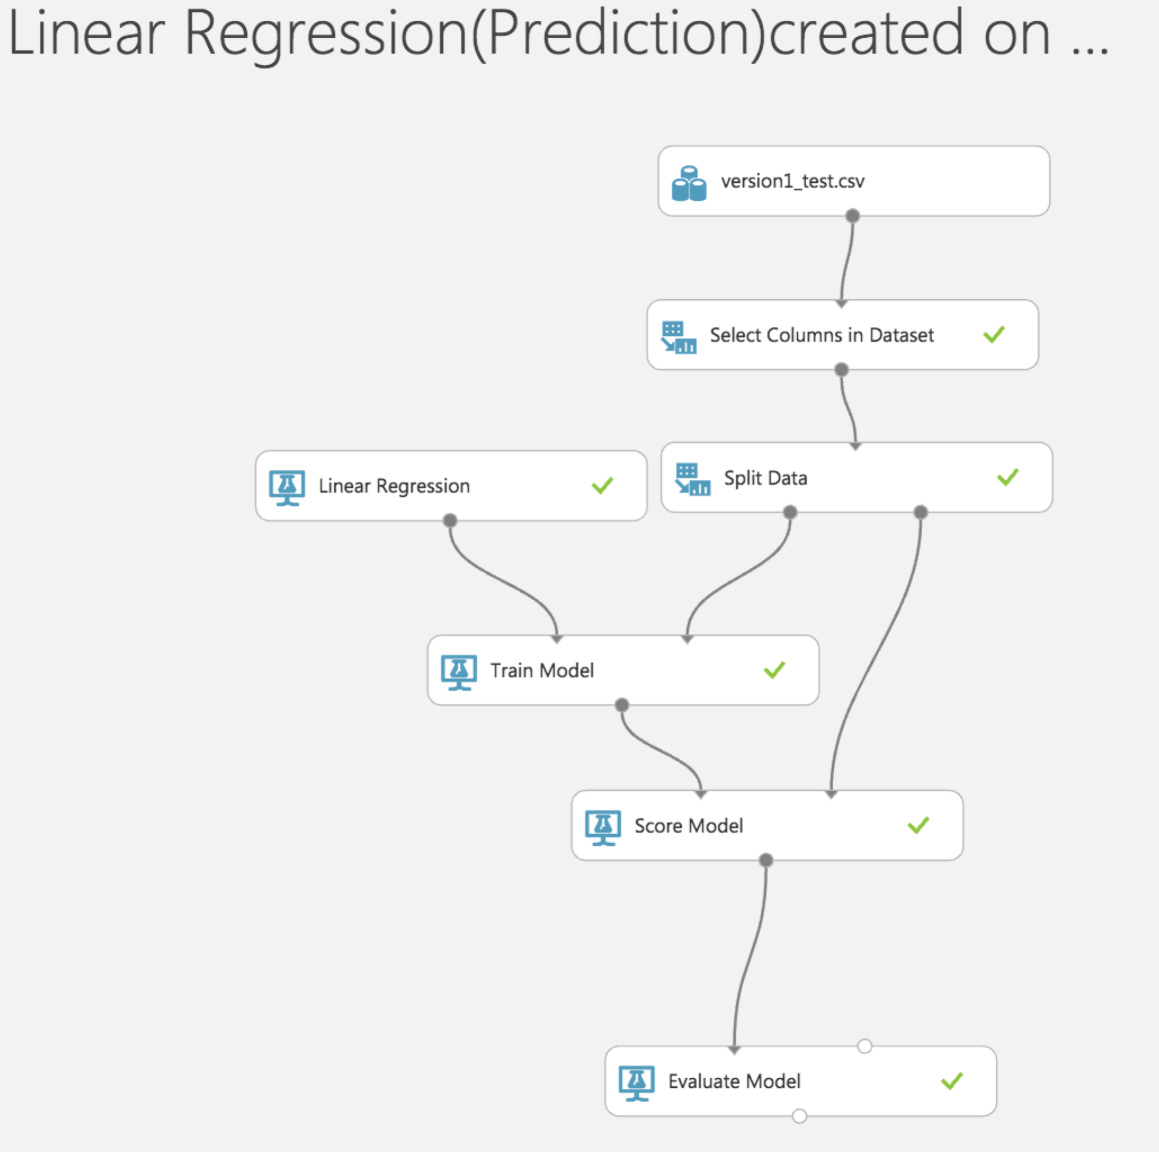

**Properties of linear Regression:**

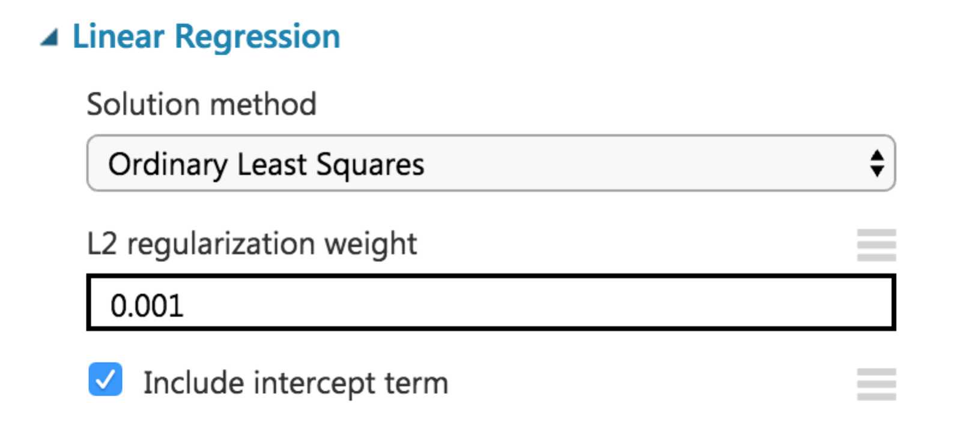

**Prediction:**

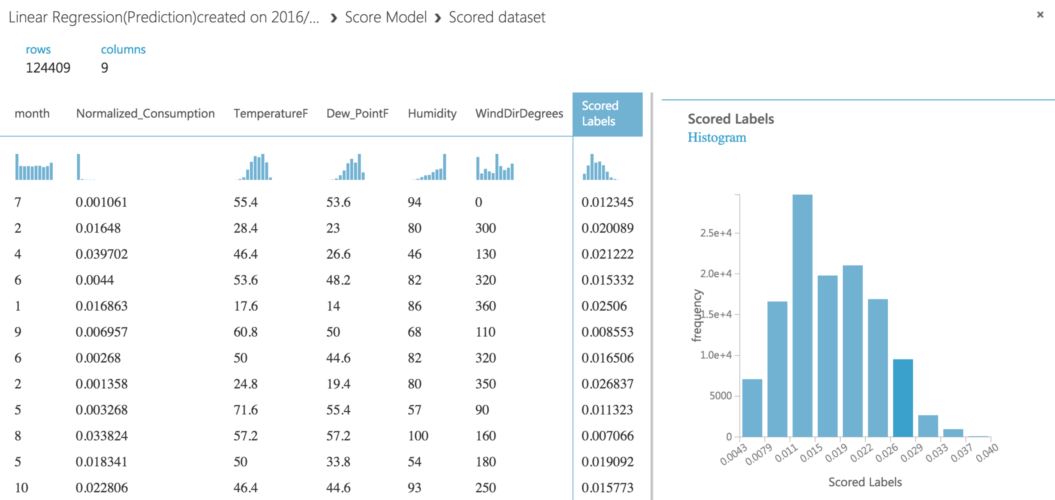

**Performance metrics:**

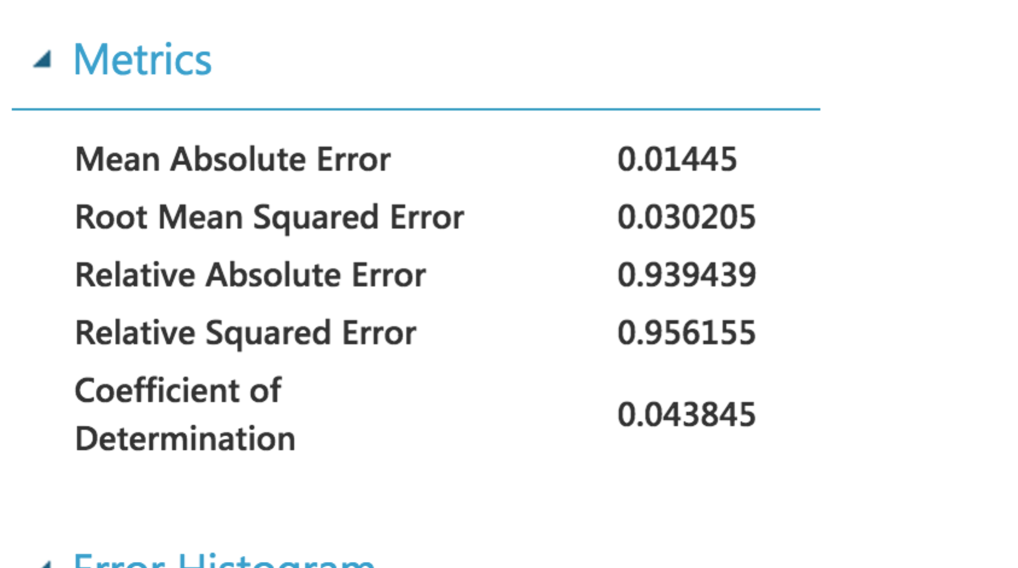

**The below graph can be used to assess the quality of regression.**

The term "error" here represents the difference between the predicted value and the true value. The error metrics measure the predictive performance of a regression model in terms of the mean deviation of its predictions from the true values. Lower error values mean the model is more accurate in making predictions. The coefficient of determination, which is also known as R squared, is also a standard way of measuring how well the model fits the data.

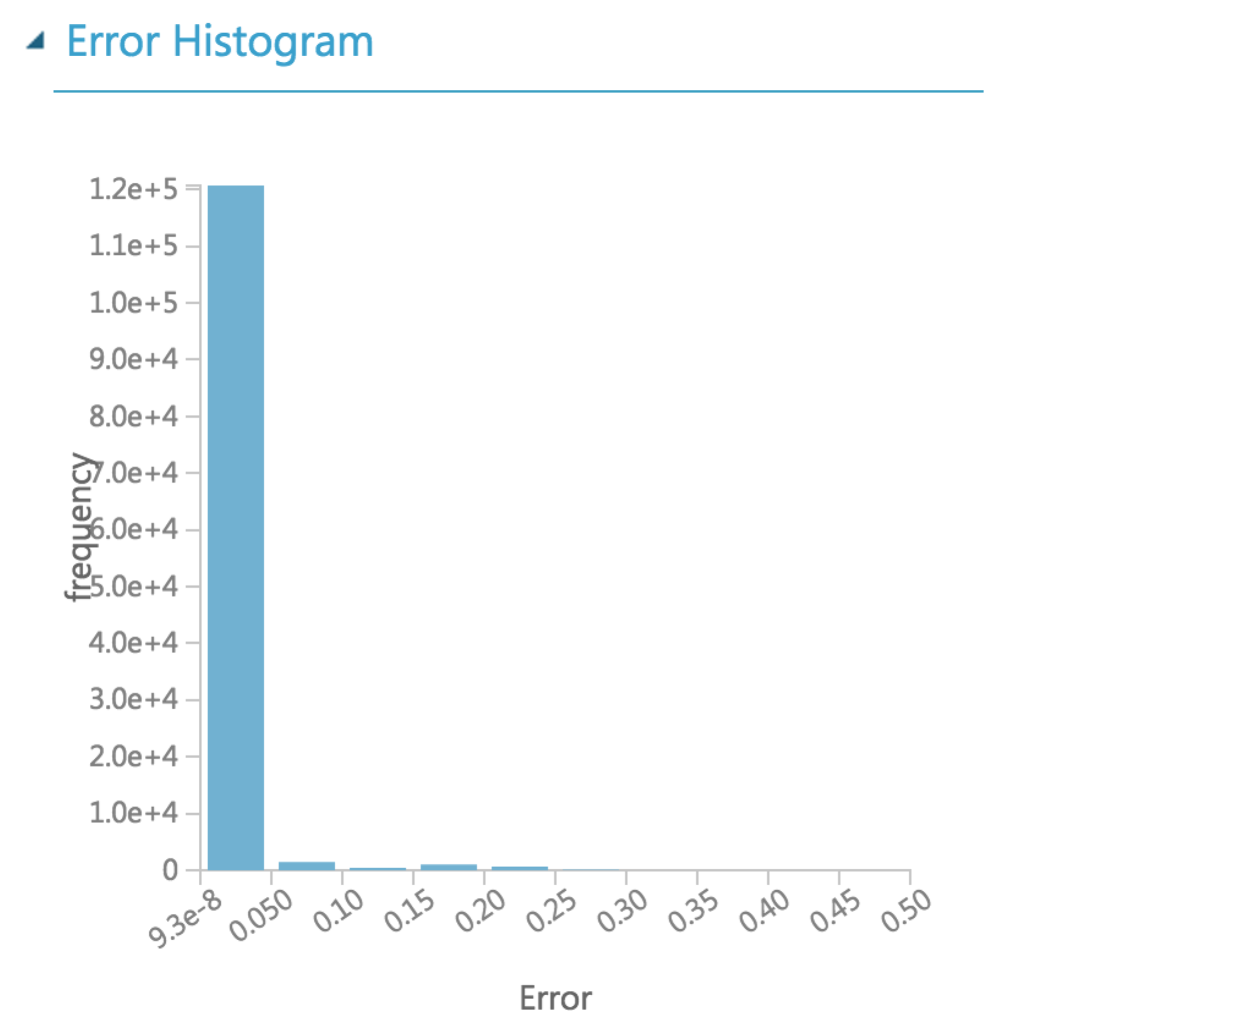

**Setting up a web service and deploying it:**

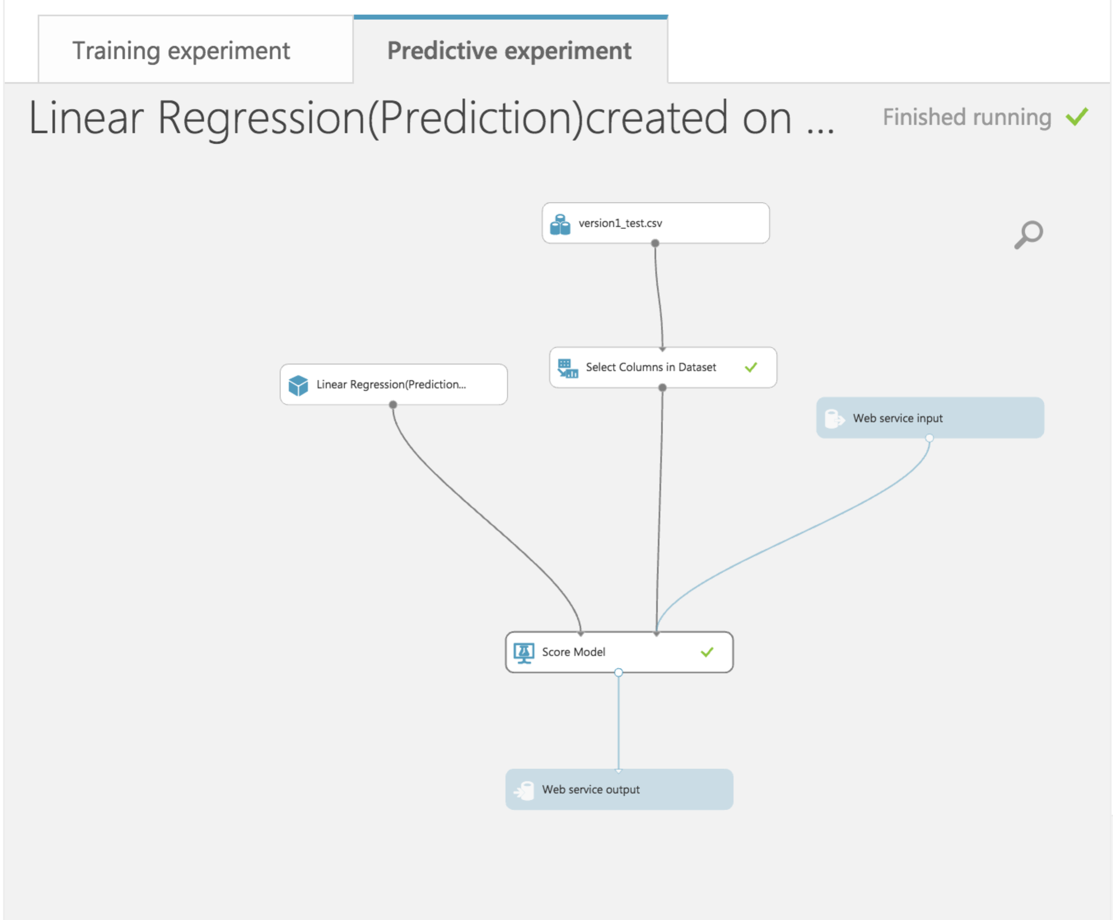

**Regression Model – Decision Forest**

Decision Forest Regression module to create a regression model using an ensemble of decision trees. Decision trees are non-parametric models that perform a sequence of simple tests for each instance, traversing a binary tree data structure until a leaf node (decision) is reached.

Advantages:

* They are efficient in both computation and memory usage during training and prediction.
* They can represent non-linear decision boundaries.
* They perform integrated feature selection and classification and are resilient in the presence of noisy features.

Disadvantage:

* Random forests have been observed to overfit for some datasets with noisy classification/regression tasks.

**Trained Model:**

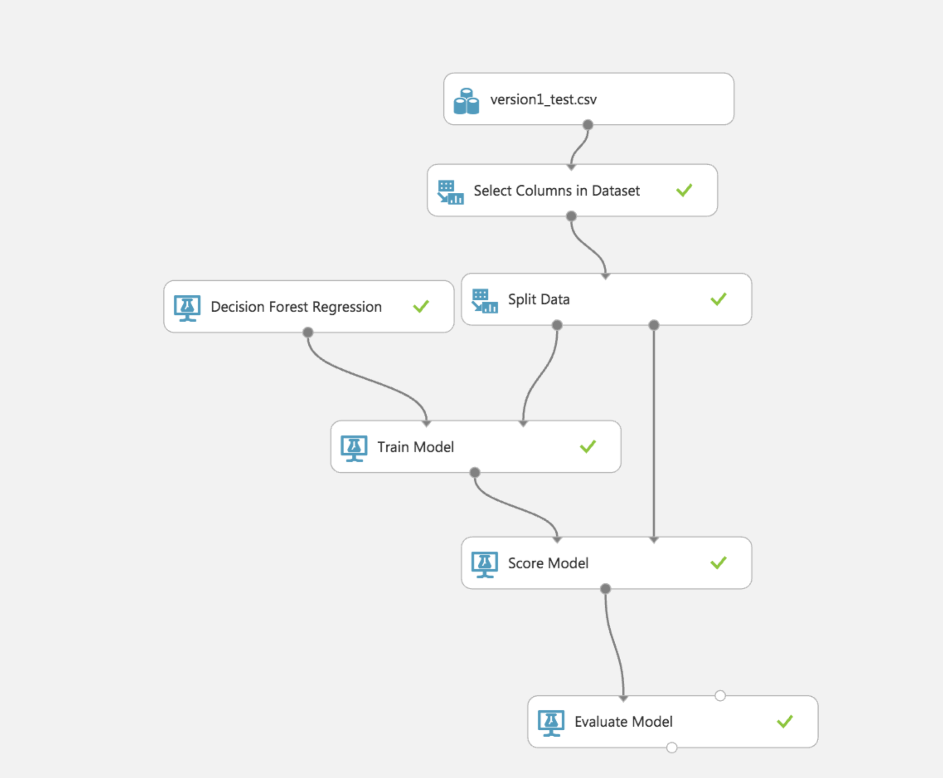

**Properties:**

**Bagging:** Bagging is also called *bootstrap aggregating*. Each tree in a regression decision forest outputs a Gaussian distribution by way of prediction. The aggregation is to find a Gaussian whose first two moments match the moments of the mixture of Gaussians given by combining all Gaussians returned by individual trees.

Number of decision trees, indicate the total number of decision trees to create in the ensemble. By creating more decision trees, you can potentially get better coverage, but training time will increase.

For Maximum depth of the decision trees, type a number to limit the maximum depth of any decision tree. Increasing the depth of the tree might increase precision, at the risk of some overfitting and increased training time.

For Number of random splits per node, type the number of splits to use when building each node of the tree. A *split* means that features in each level of the tree (node) are randomly divided.

For Minimum number of samples per leaf node, indicate the minimum number of cases that are required to create any terminal node (leaf) in a tree.

By increasing this value, you increase the threshold for creating new rules.

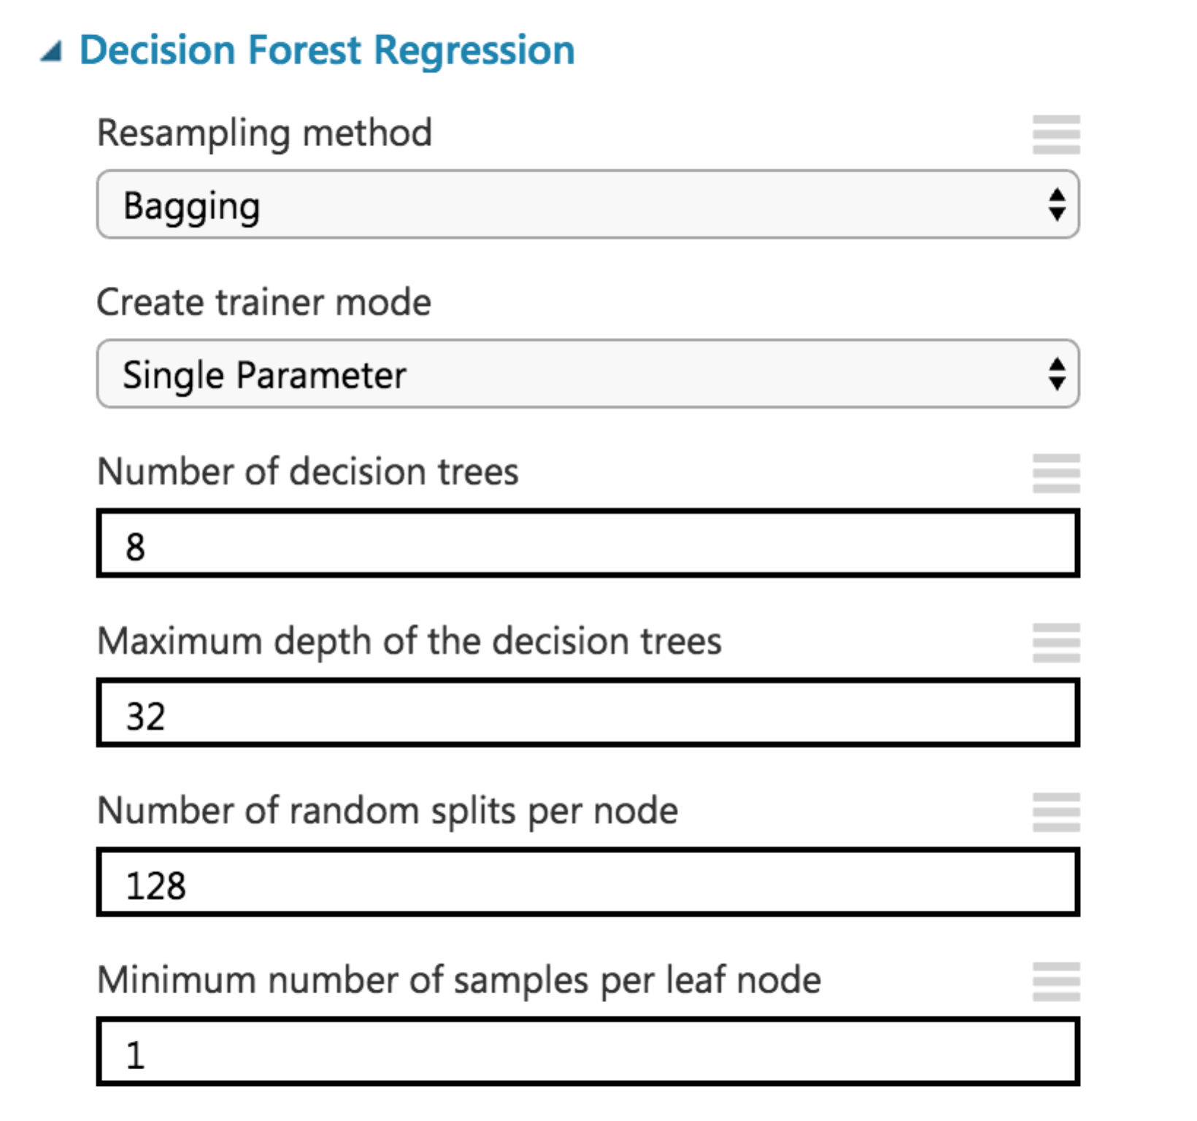

**Prediction:**

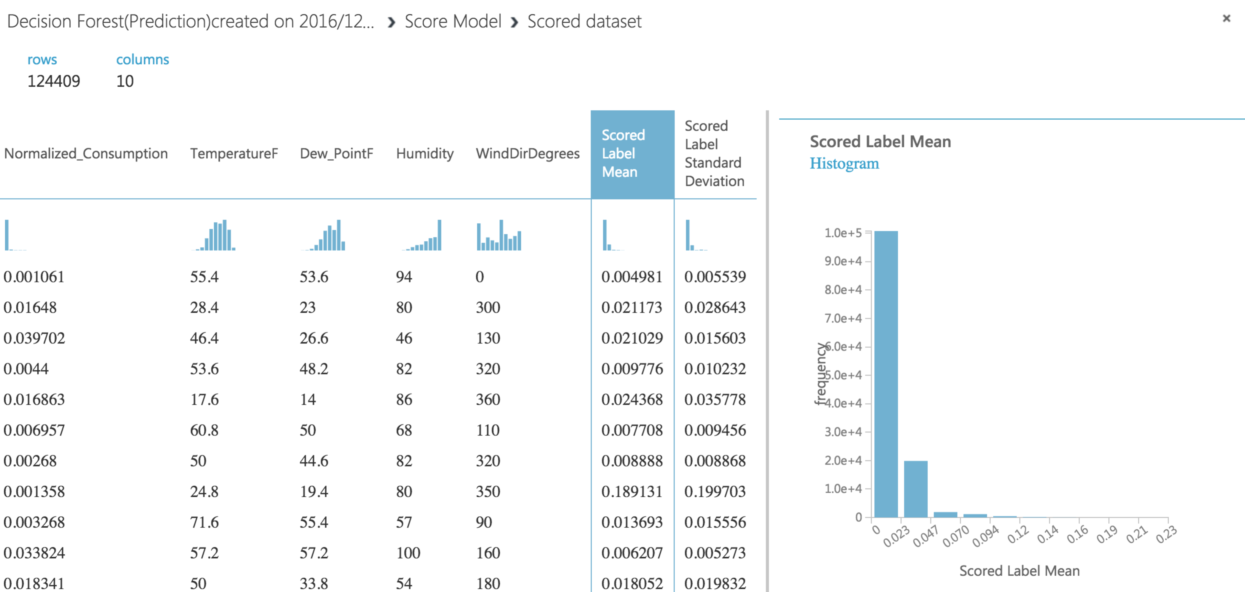

**Performance Matrix:**

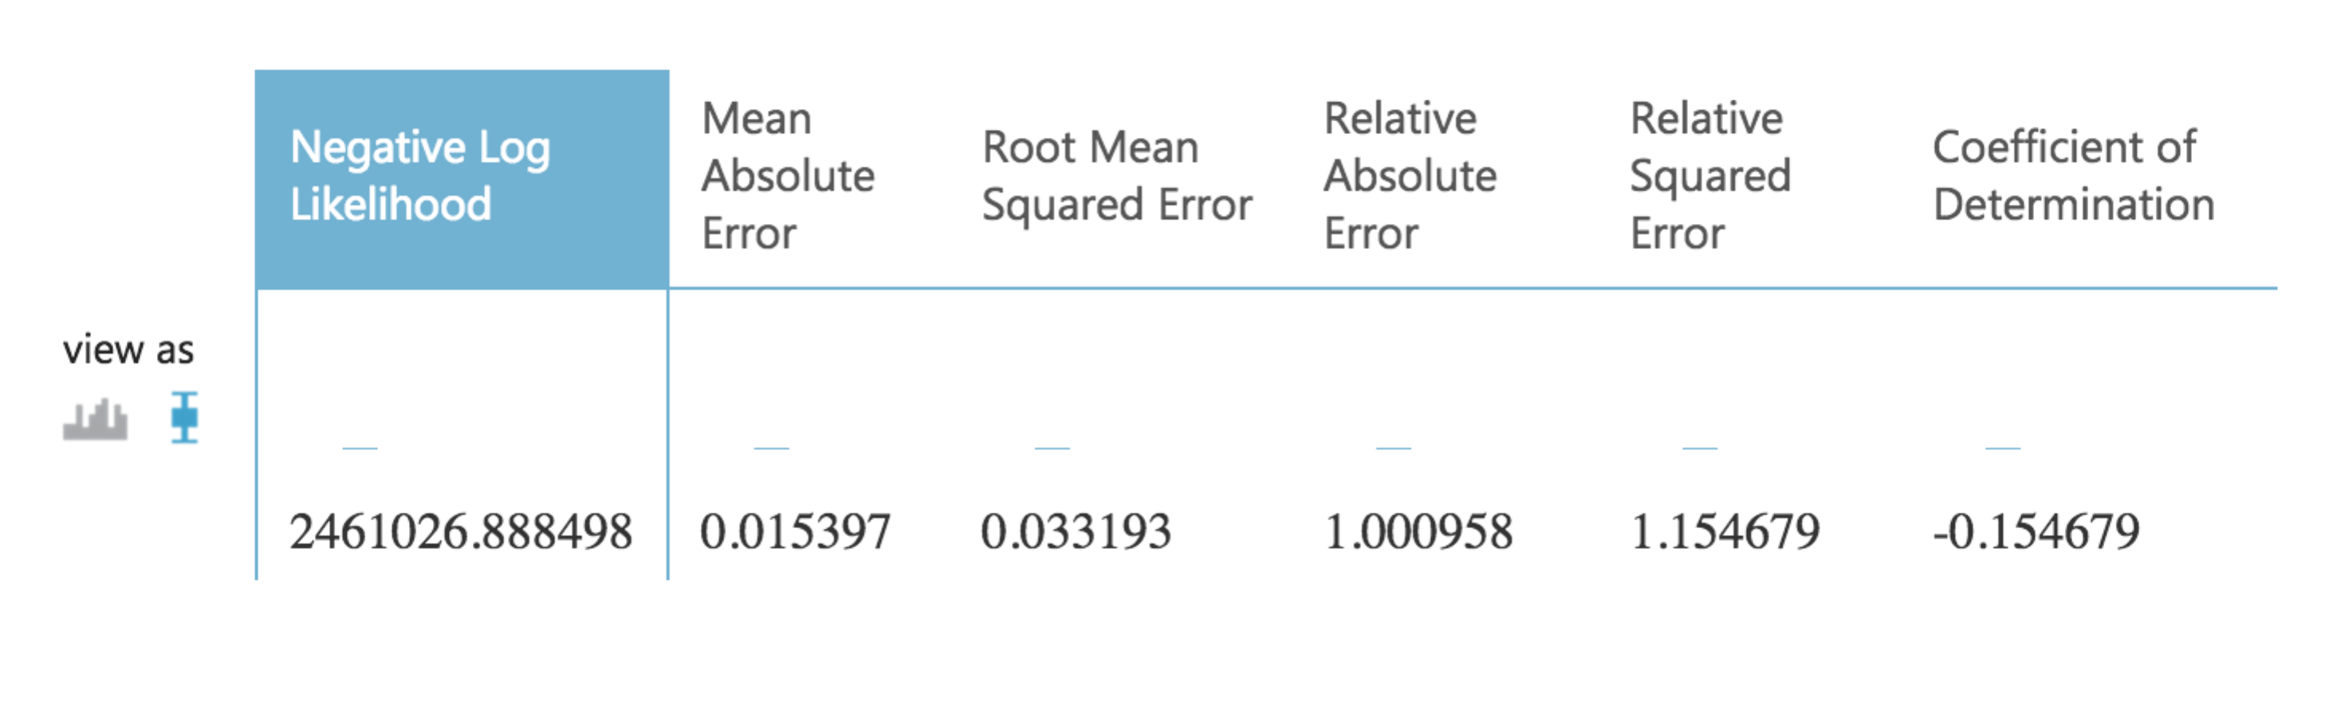

**Setting up a web service and deploying it:**

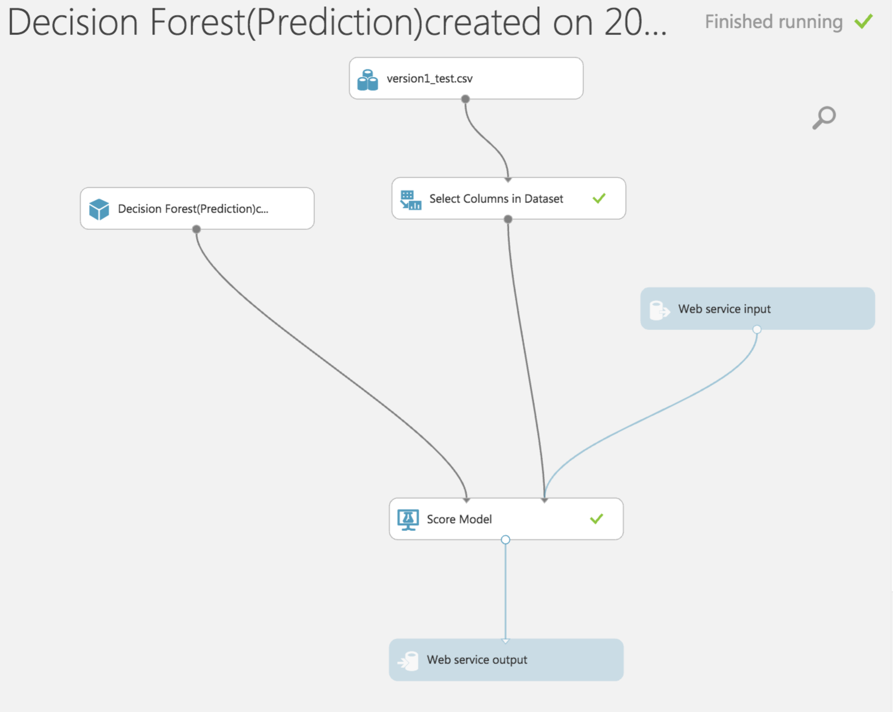

**Regression Model – Decision Tree**

Boosted Decision Tree Regression module to create an ensemble of regression trees using boosting. Boosting means that each tree is dependent on prior trees, and learns by fitting the residual of the trees that preceded it. Thus, boosting in a decision tree ensemble tends to improve accuracy with some small risk of less coverage.

Advantages:

* Decision trees implicitly perform variable screening or feature selection
* Decision trees require relatively little effort from users for data preparation
* Nonlinear relationships between parameters do not affect tree performance
* The best feature of using trees for analytics - easy to interpret and explain

Disadvantages:

* They can be extremely sensitive to small perturbations in the data: a slight change can result in a drastically different tree.
* They can easily overfit.
* They can have problems out-of-sample prediction (this is related to them being non-smooth).

**Trained model:**

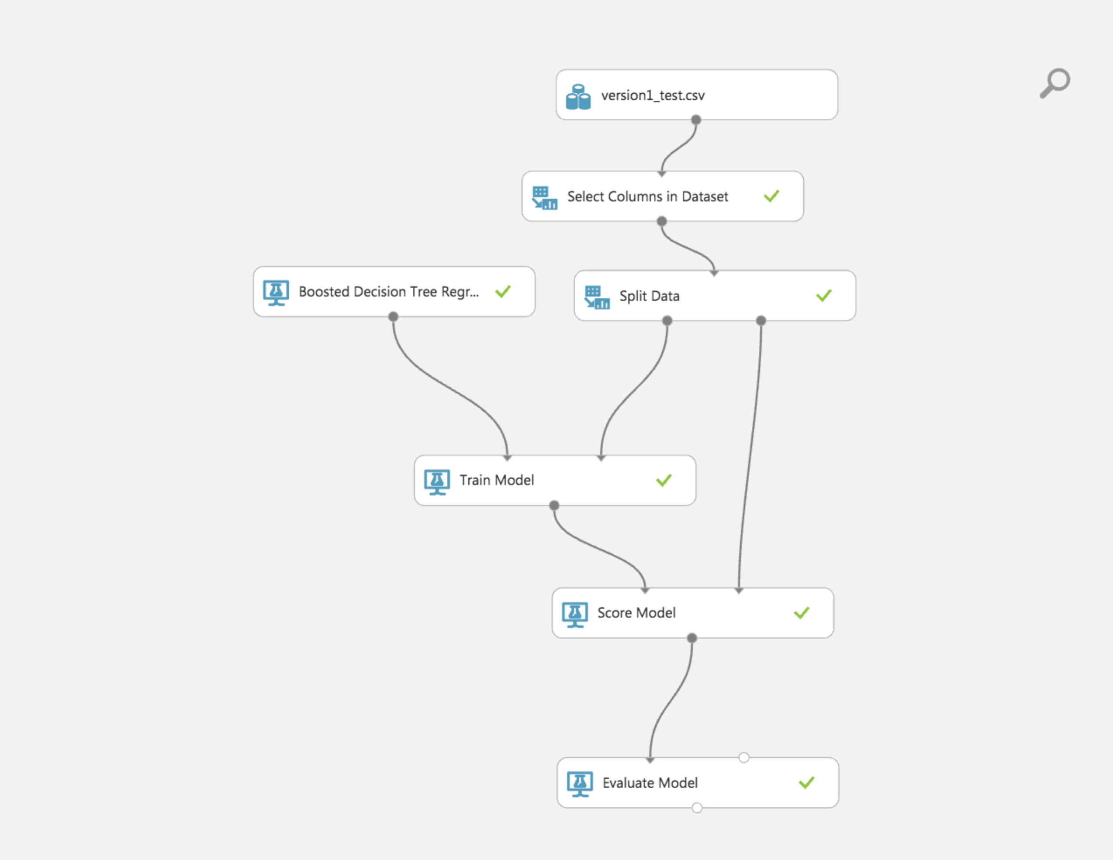

**Properties:**

**Maximum number of leaves per tree**, indicate the maximum number of terminal nodes (leaves) that can be created in any tree.

By increasing this value, you potentially increase the size of the tree and get better precision, at the risk of overfitting and longer training time.

For **Minimum number of samples per leaf node**, indicate the minimum number of cases required to create any terminal node (leaf) in a tree.

By increasing this value, you increase the threshold for creating new rules.

For **Learning rate**, type a number between 0 and 1 that defines the step size while learning.

The learning rate determines how fast or slow the learner converges on the optimal solution.

For **Number of trees constructed**, indicate the total number of decision trees to create in the ensemble. By creating more decision trees, you can potentially get better coverage, but training time will increase.

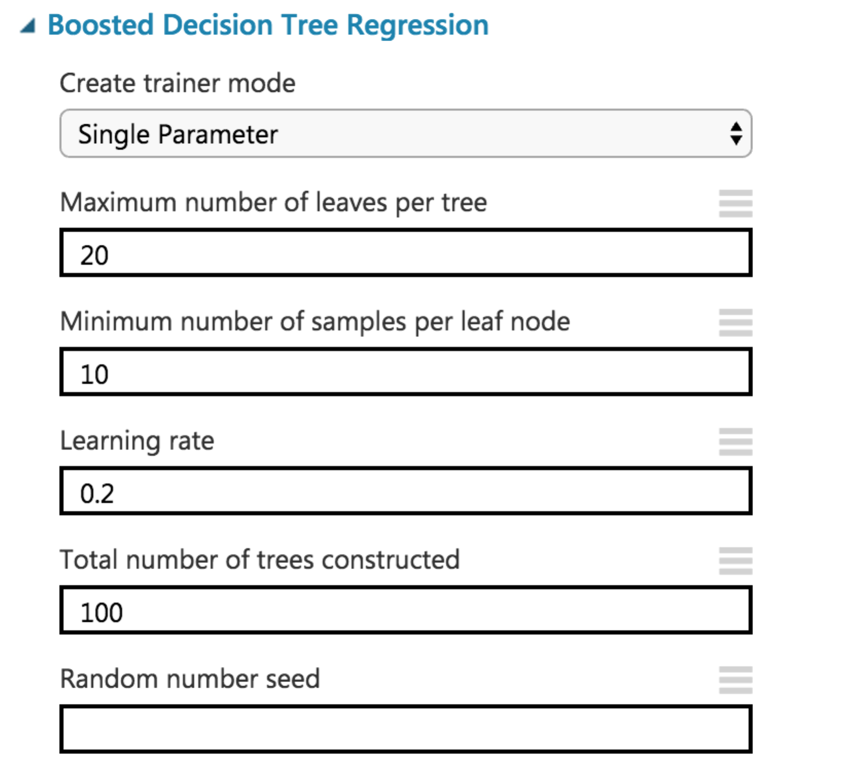

**Prediction:**

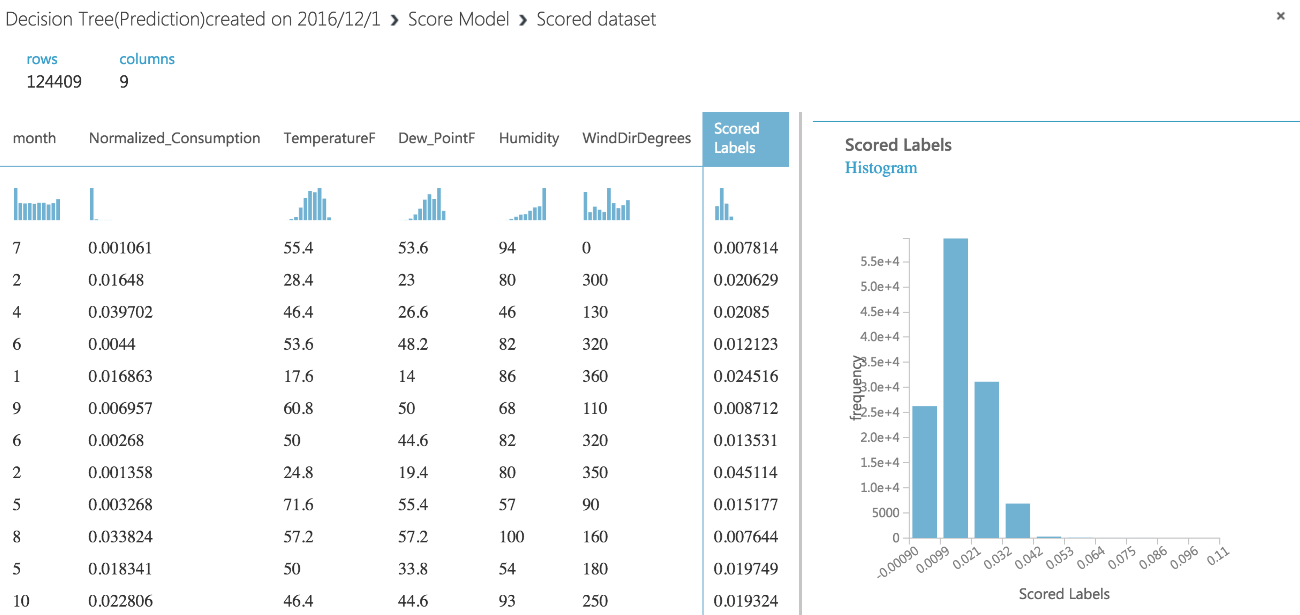

**Performance Matrix:**

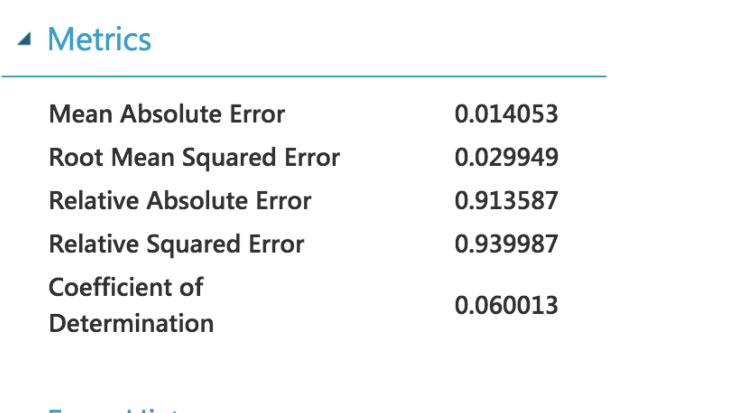

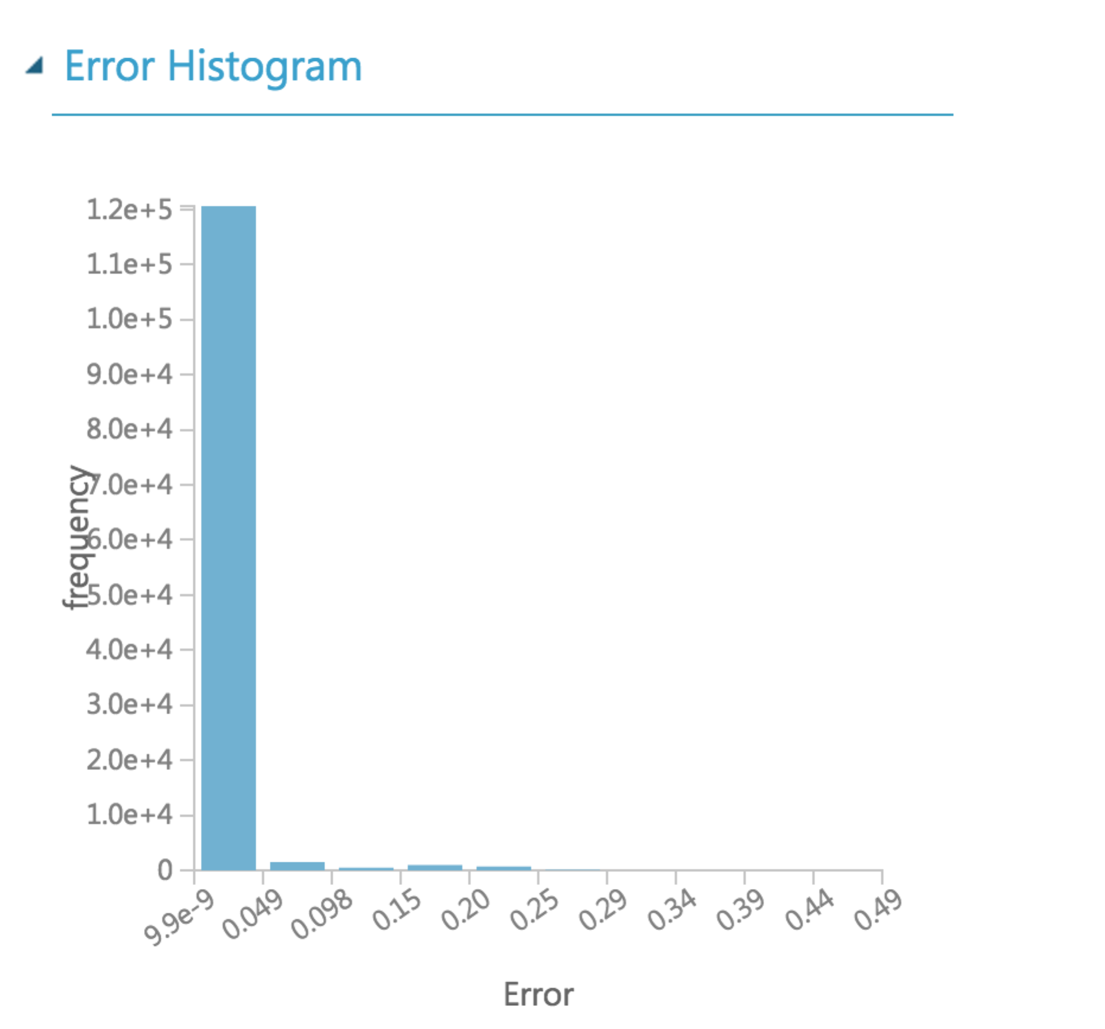

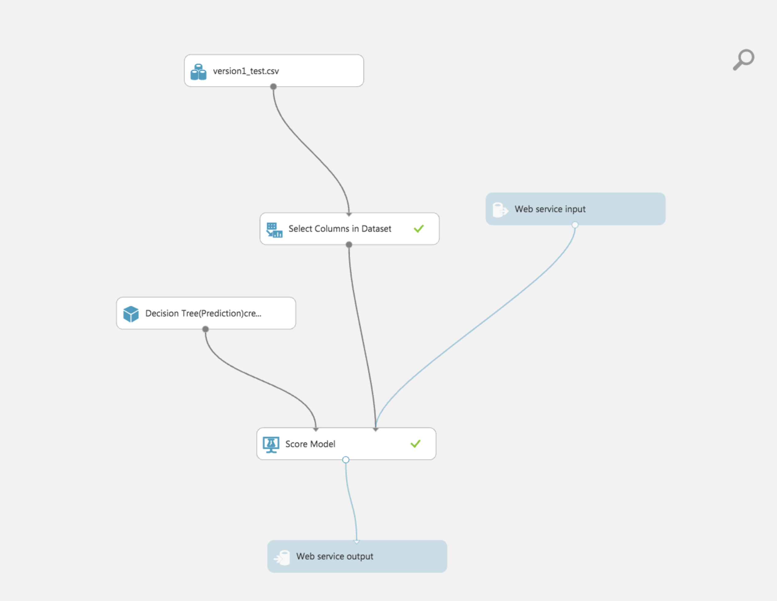

**Regression Model – Neural Network**

**Neural Network Regression** module used to create a regression model using a customizable neural network algorithm.

Neural network regression is a supervised learning method, and therefore requires a *tagged dataset*, which includes a label column. Because a regression model predicts a numerical value, the label column must be a numerical data type.

Advantages:

* Easy to conceptualize
* Lots of libraries /implementations available

Disadvantages:

* There are alternatives that are simpler, faster, easier to train, and provide better performance (svm, decision trees, regression)
* Multi-layer neural networks are usually hard to train, and require tuning lots of parameters

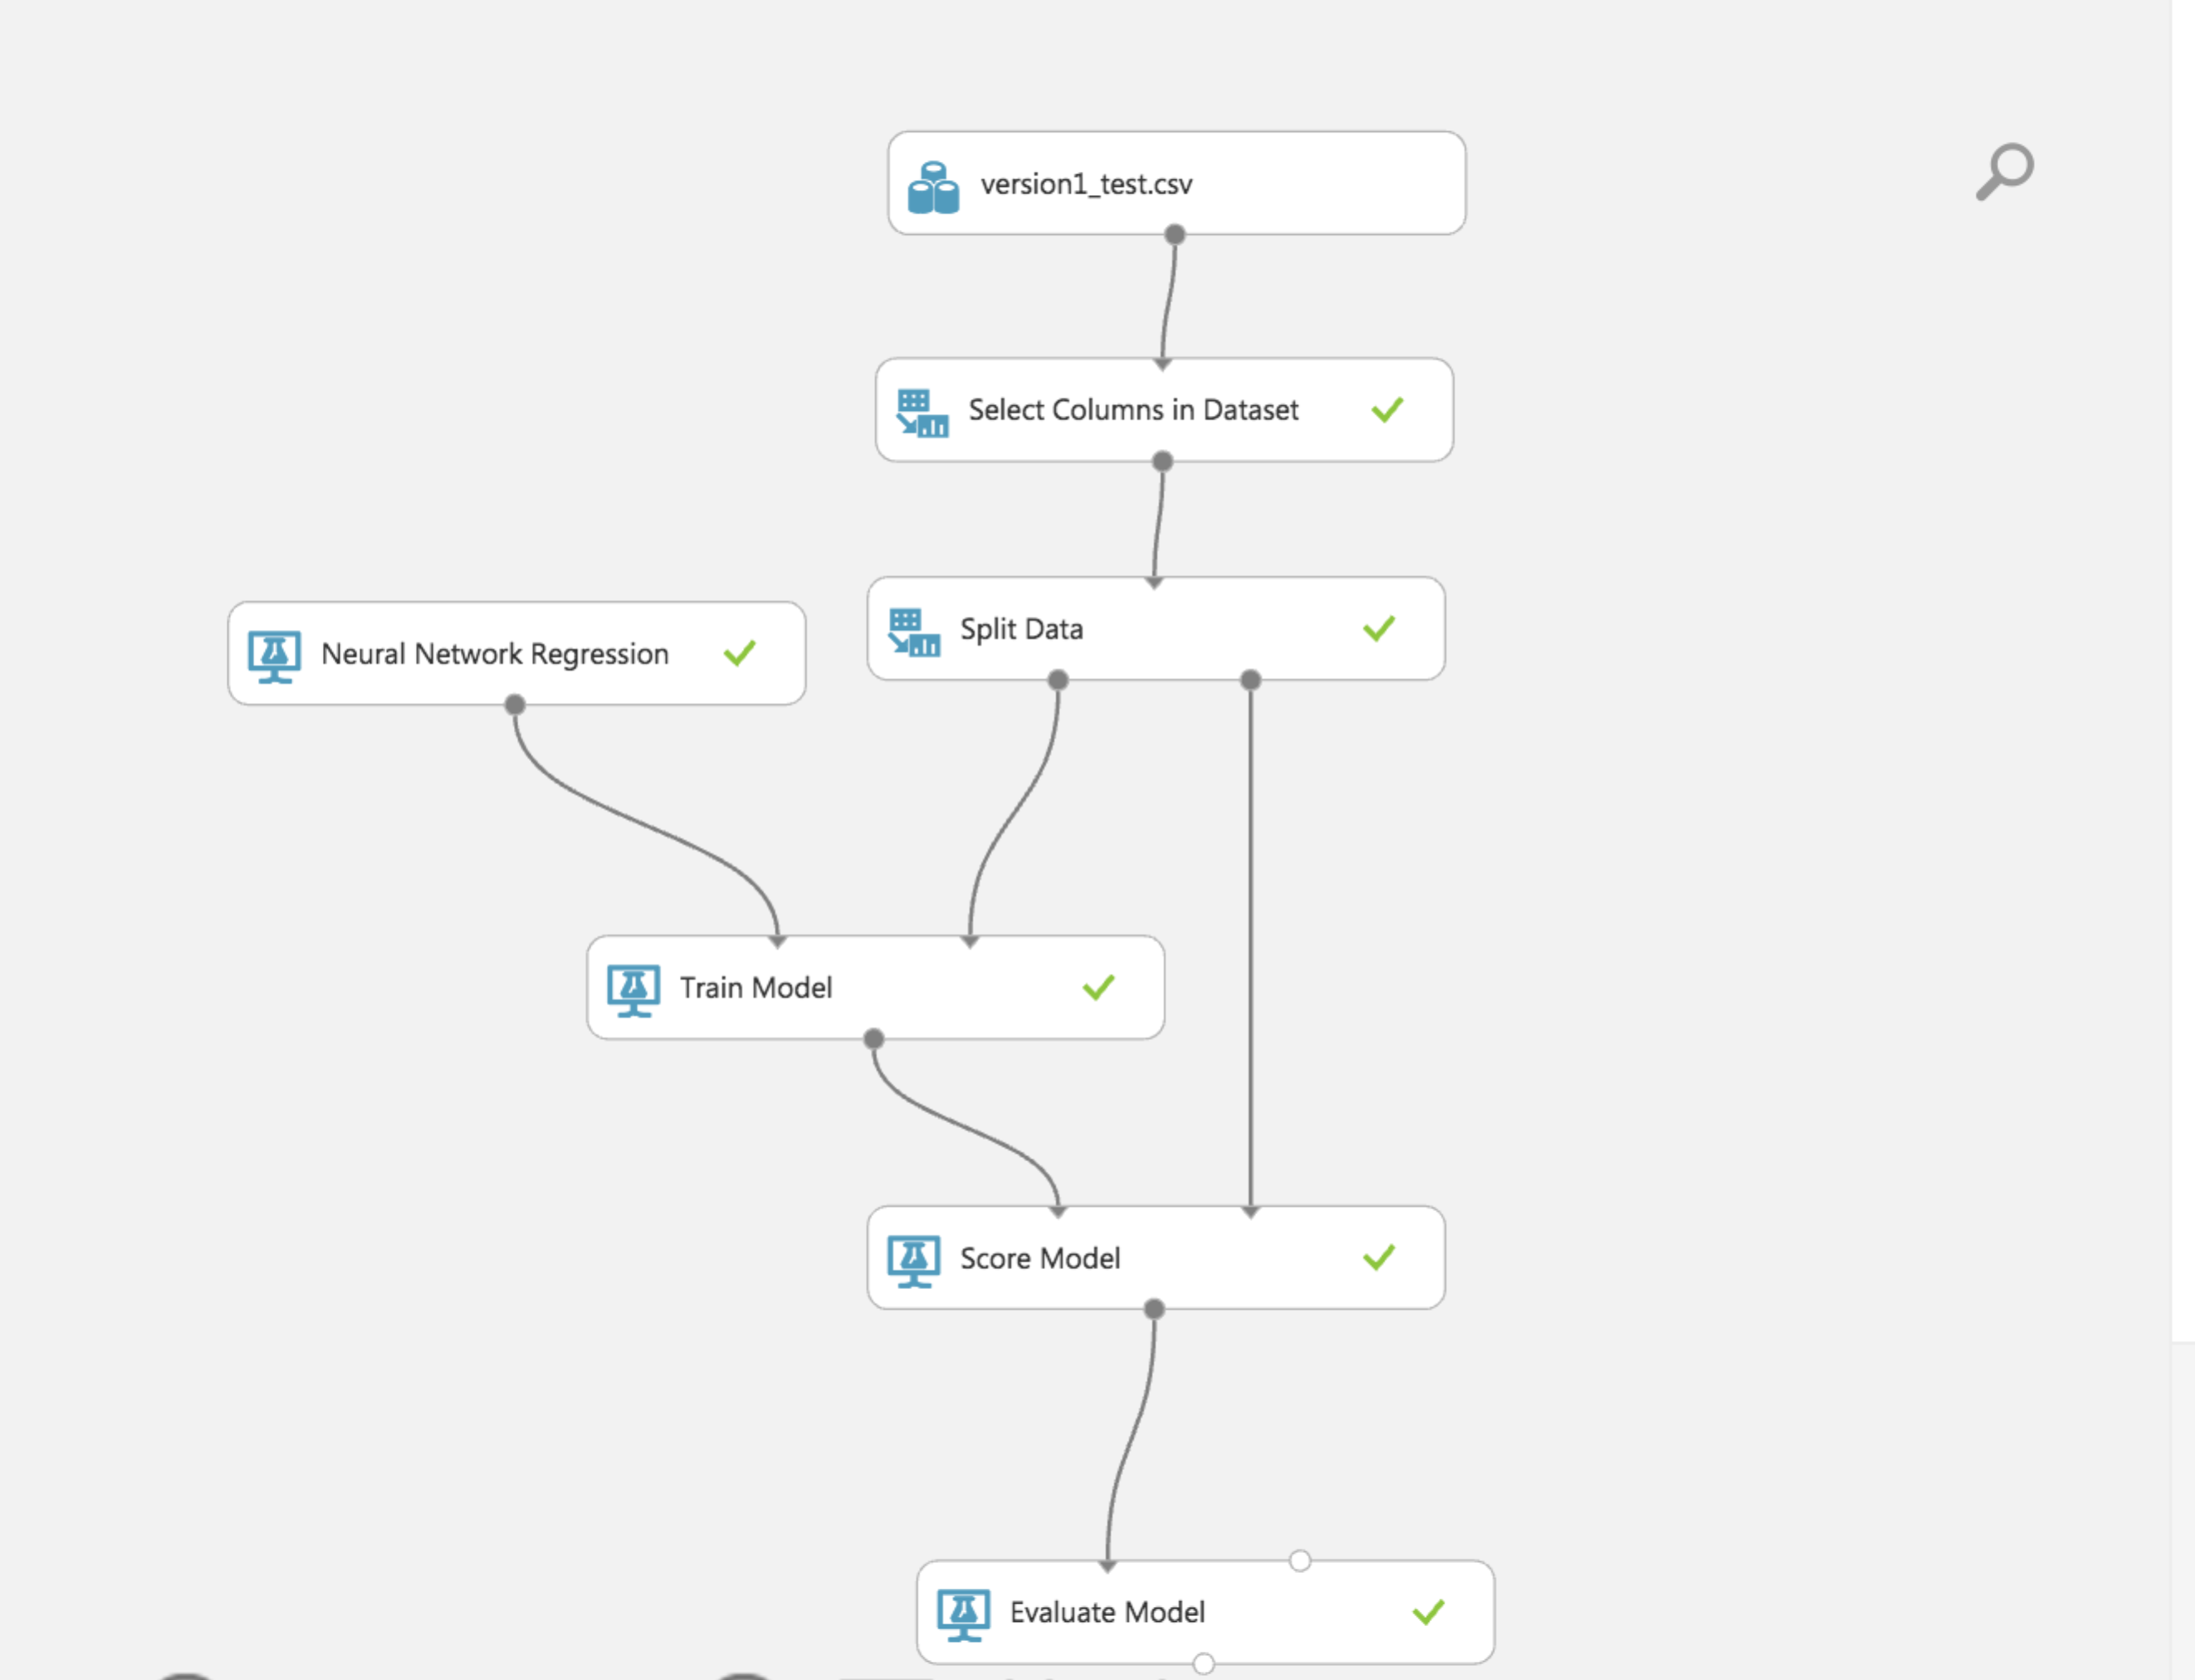

**Properties:**

**Fully connected case:** This option creates a model using the default neural network architecture, which for a neural network regression model, has these attributes:

* one hidden layer
* output layer is fully connected to the hidden layer and hidden layer is fully connected to the input layer
* no. of node: 100

Learning rate: A larger value for learning rate can cause the model to converge faster, but it can overshoot local minima.

Number of learning iterations, specify the maximum number of times the algorithm processes the training cases.

For **The initial learning weights diameter** , type a value that determines the node weights at the start of the learning process.

For **The momentum**, type a value to apply during learning as a weight on nodes from previous iterations.

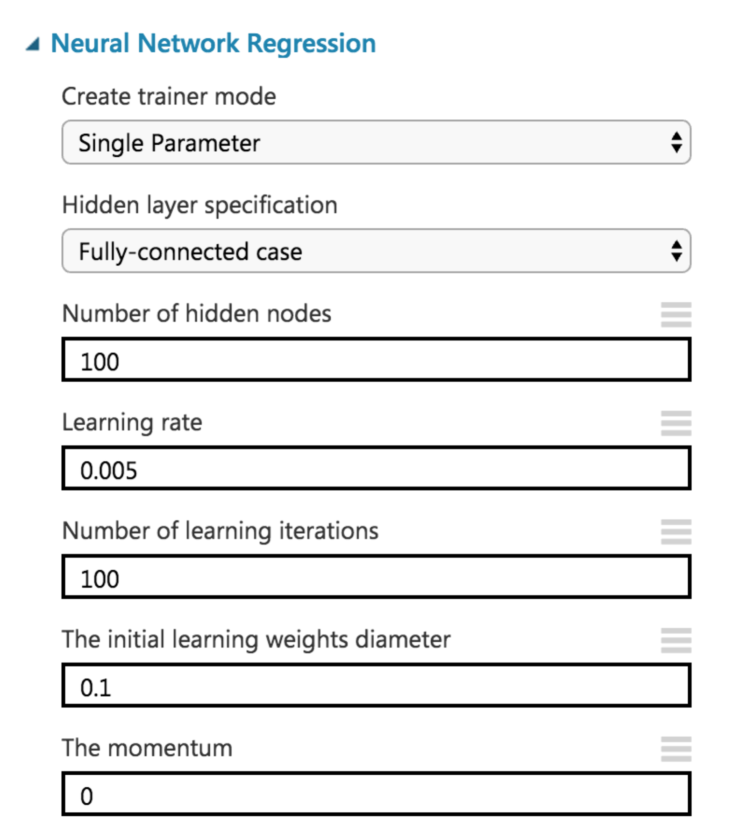

**Prediction:**

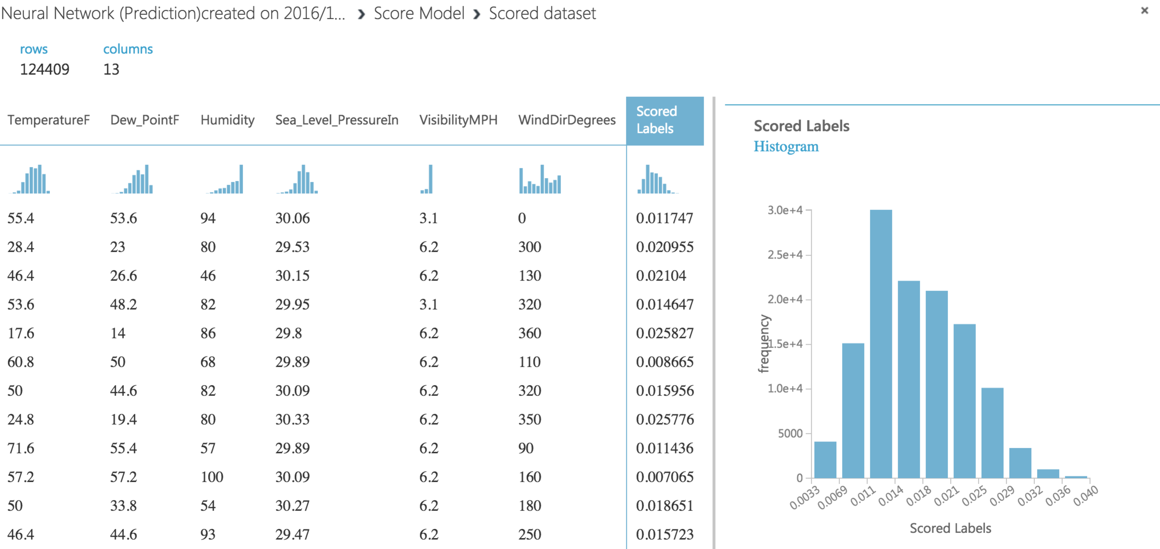

**Performance Metrics:**

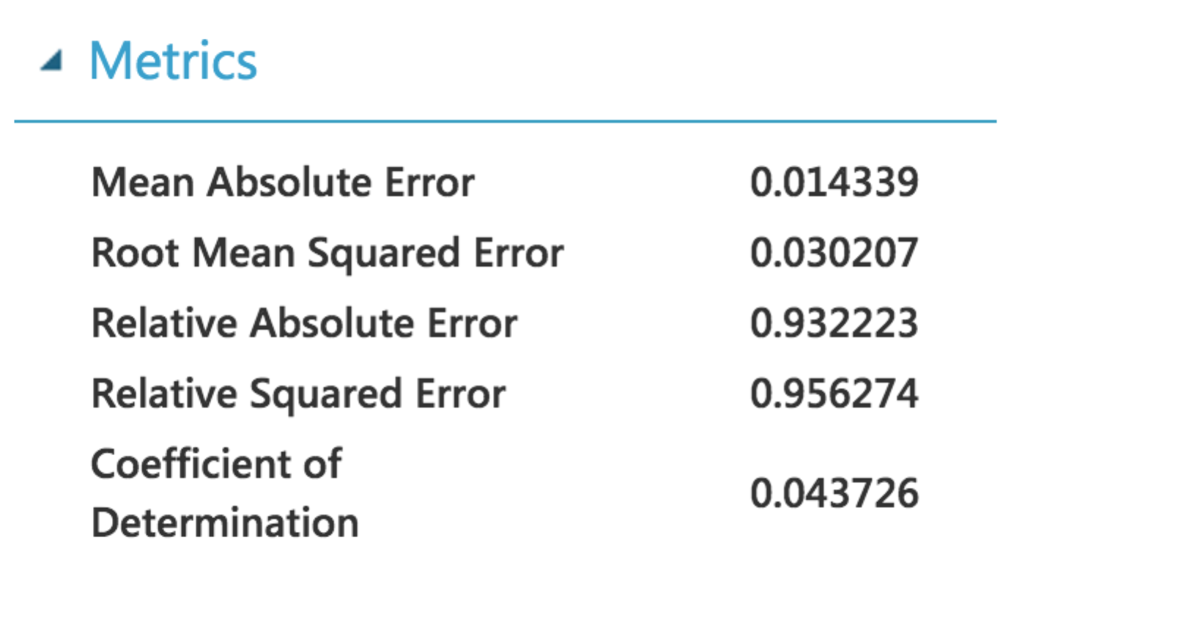

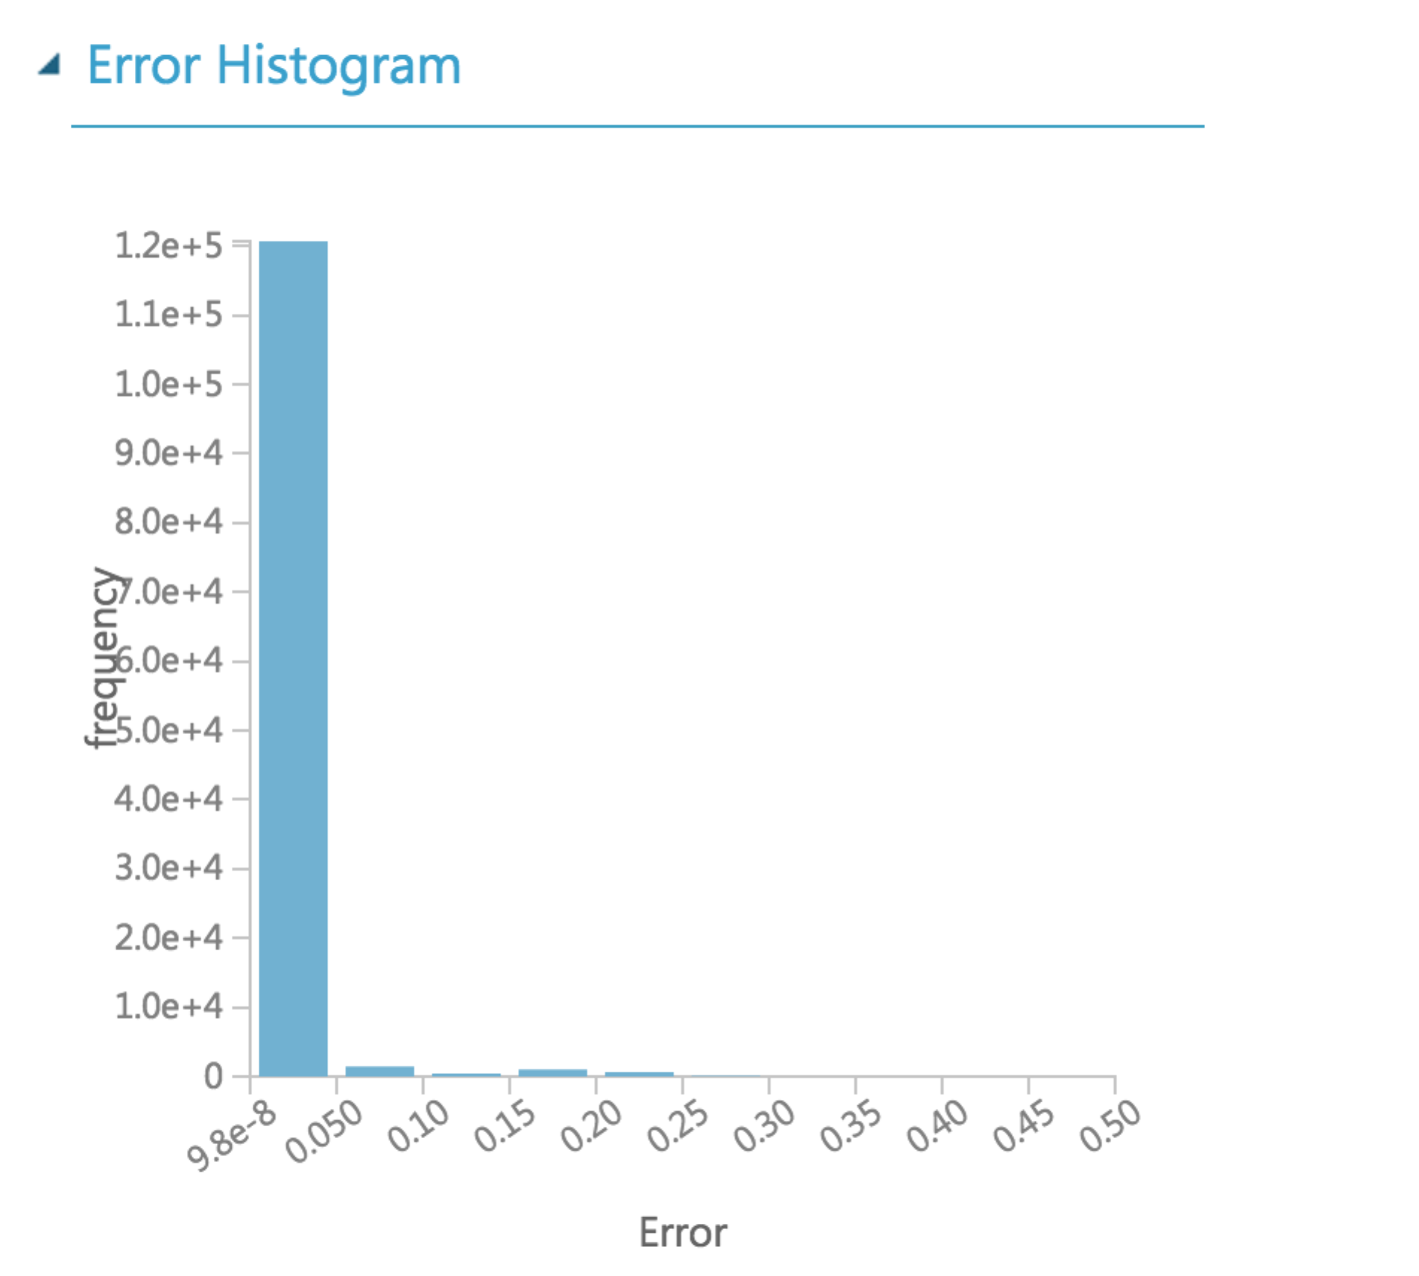

**Comparison :**

|  |  |
| --- | --- |
| **Model** | **Performance Metrics** |
| 1. **Linear Regression** |  |
| 1. **Decision Forest** |  |
| 1. **Decision Tree** |  |
| 1. **Neural Network** |  |

**Result: The model with least root mean squared error and mean absolute error is Decision Tree and it has the highest coefficient of determination, 60**

**Classification**: Classification algorithms predict the class or category for a single instance of data.

**Classification Model – Logistic Regression**

Logistic regression is a well-known method in statistics that is used to predict the probability of an outcome, and is particularly popular for classification tasks. The algorithm predicts the probability of occurrence of an event by fitting data to a logistic function.

Advantages/Disadvantages:

* Logistic regression will work better if there's a single decision boundary, not necessarily parallel to the axis.
* Logistic regression is intrinsically simple, it has low variance and so is less prone to over-fitting.
* requires large sample size to achieve stable results.

**Trained model:**

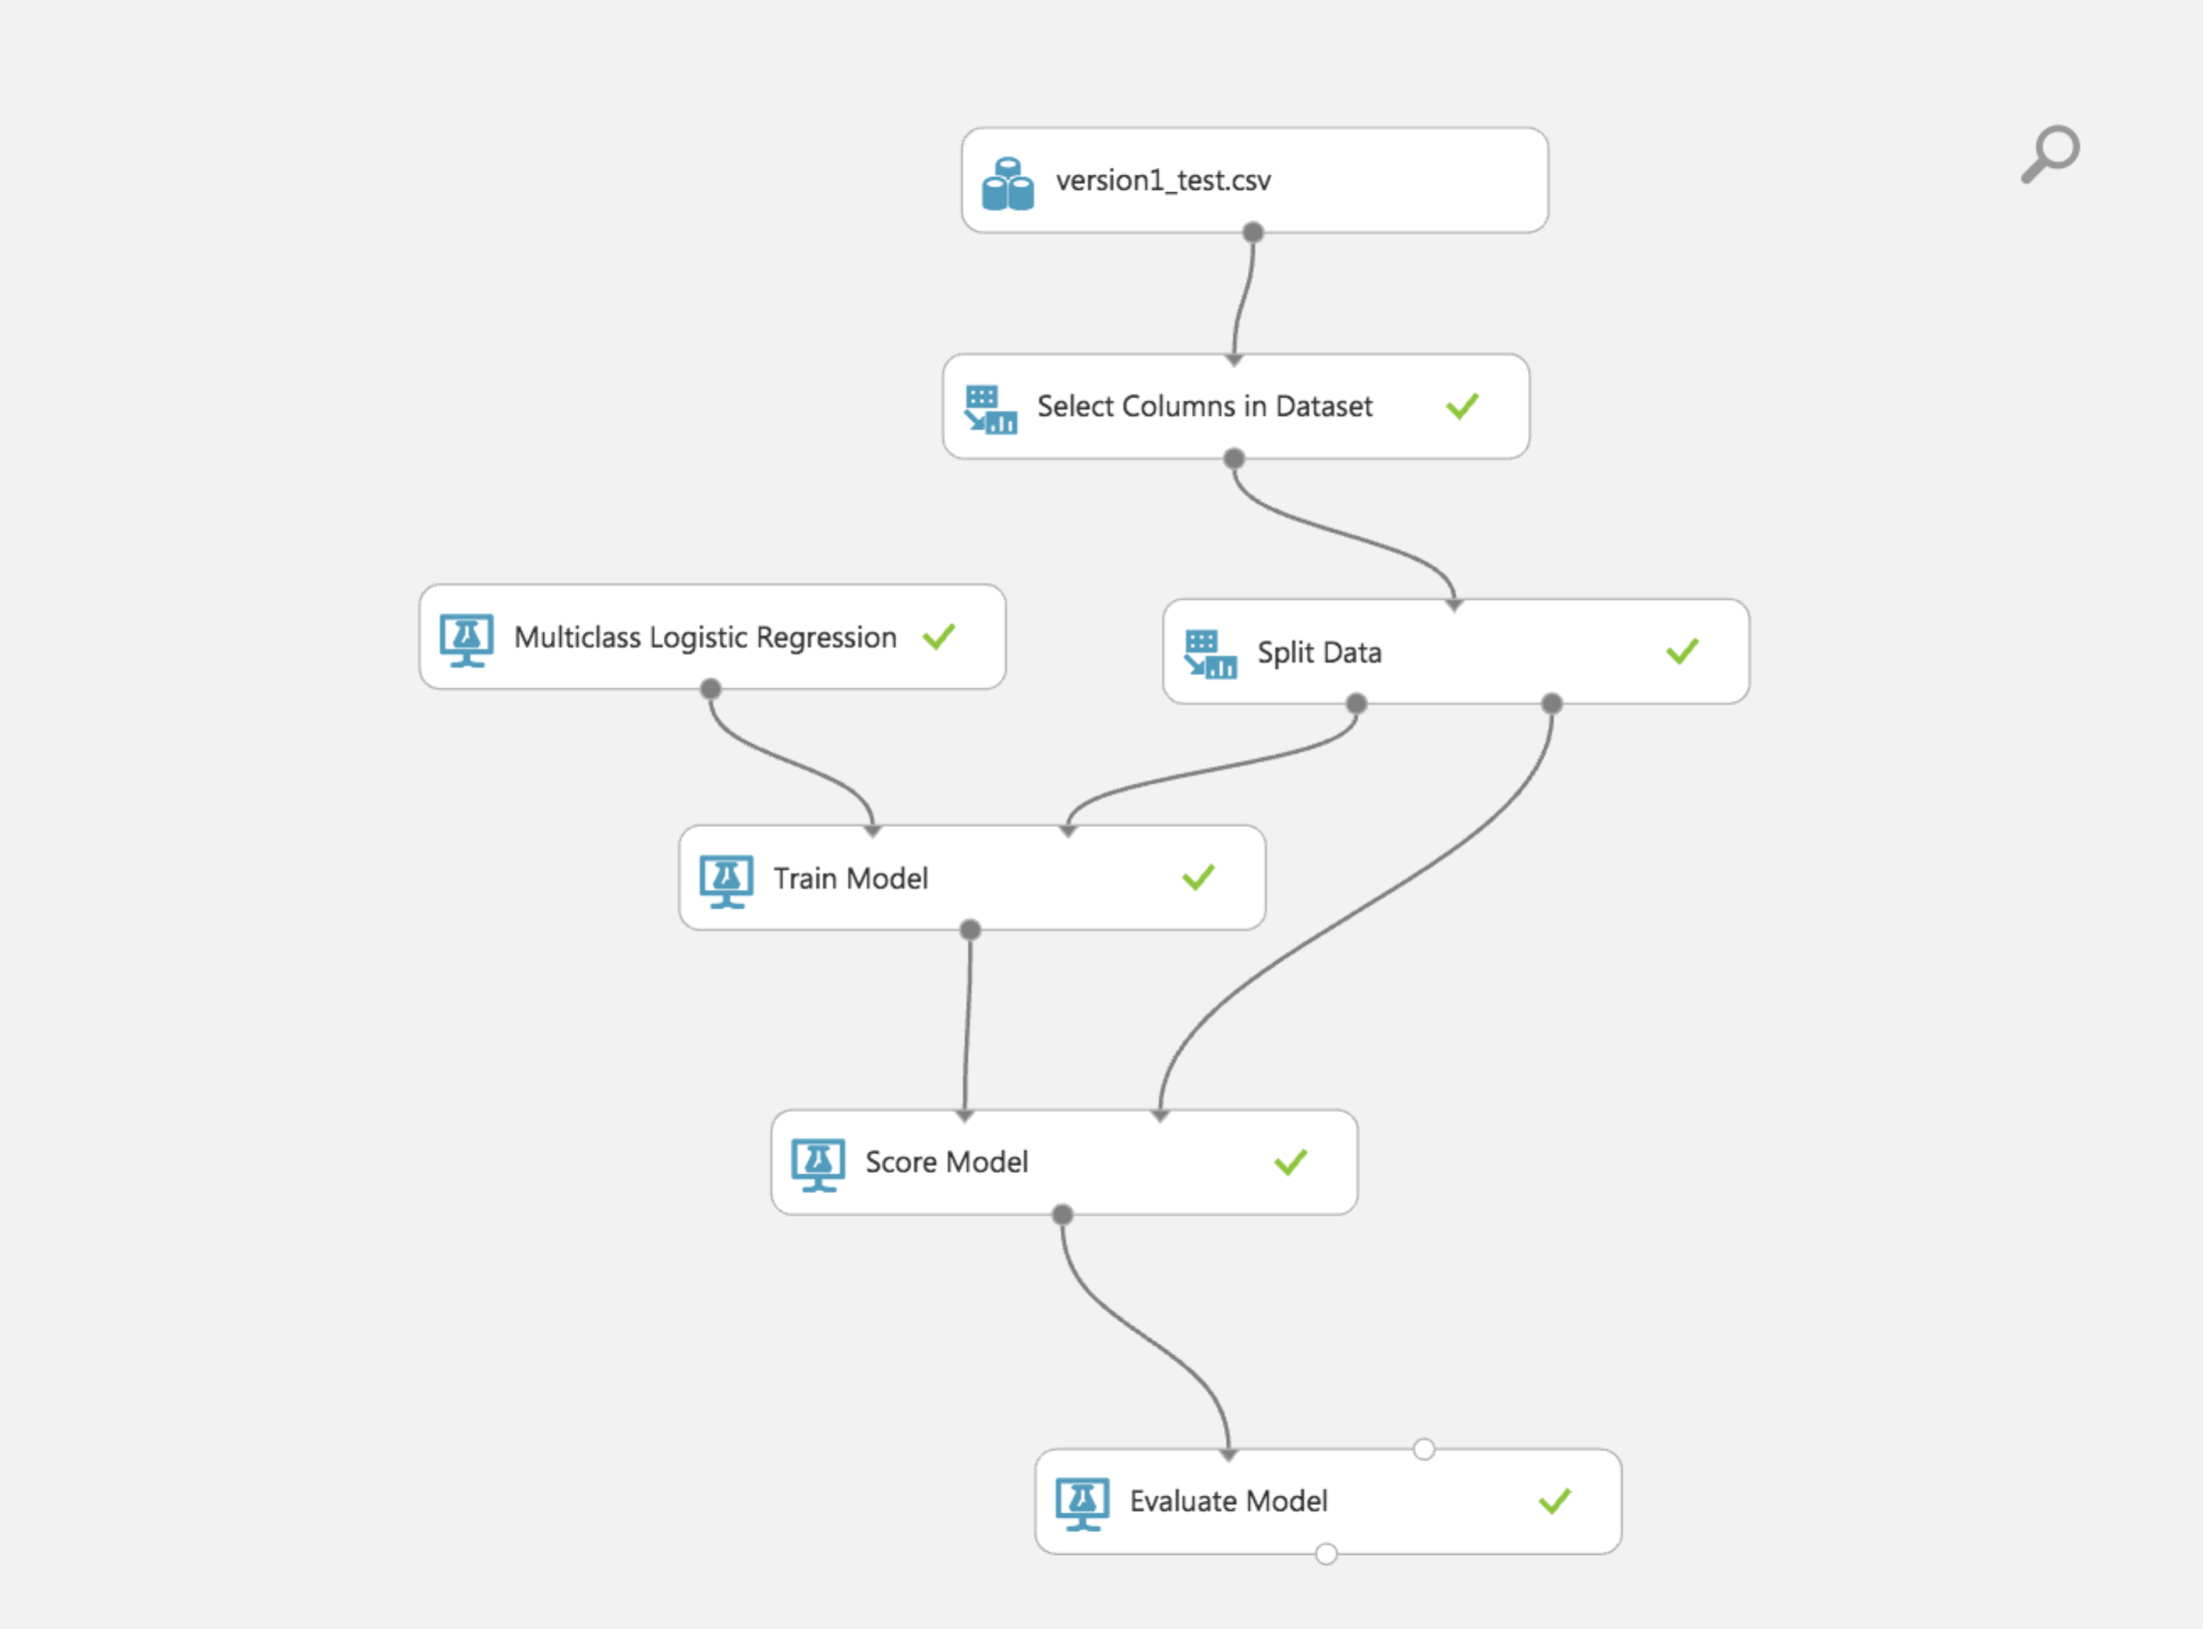

**Properties:**

For **Optimization tolerance**, specify the threshold value for optimizer convergence. If the improvement between iterations is less than the threshold, the algorithm stops and returns the current model.

**L1 regularization weight**: Regularization is a method for preventing overfitting by penalizing models with extreme coefficient values. Regularization works by adding the penalty that is associated with coefficient values to the error of the hypothesis. An accurate model with extreme coefficient values would be penalized more, but a less accurate model with more conservative values would be penalized less. L1 can be applied to sparse models, which is useful when working with high-dimensional data.

**Memory size** for L-BFGS: specify the amount of memory to use for L-BFGS optimization. This parameter indicates the number of past positions and gradients to store for the computation of the next step.

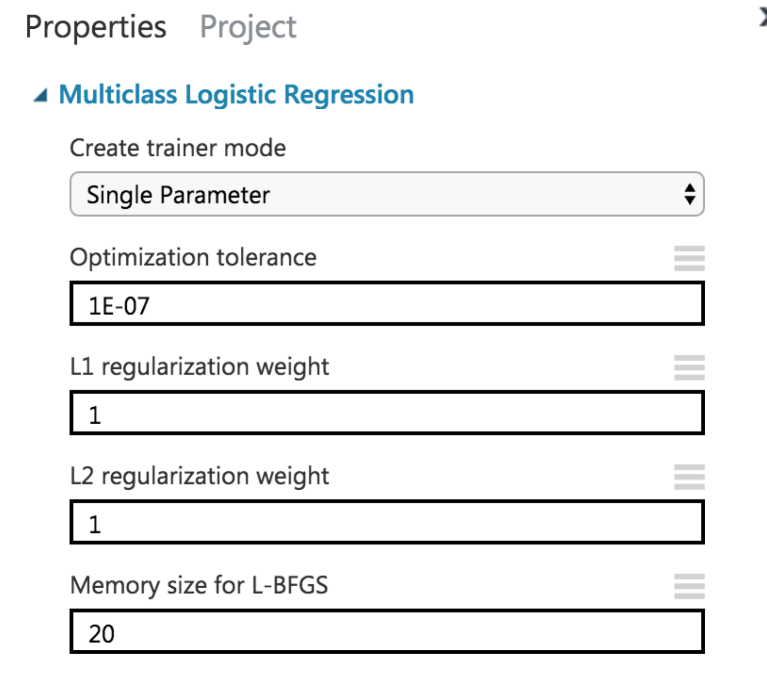

**Classification Results:**

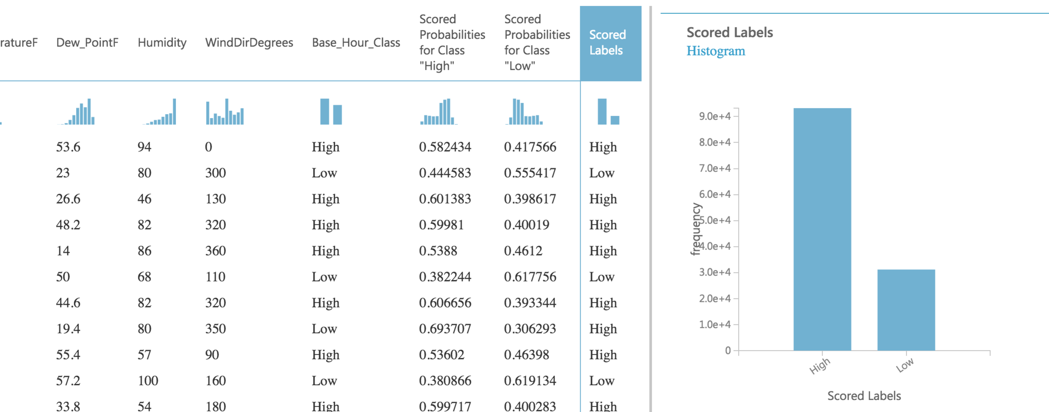

**Performance Metric and Confusion matrix:**

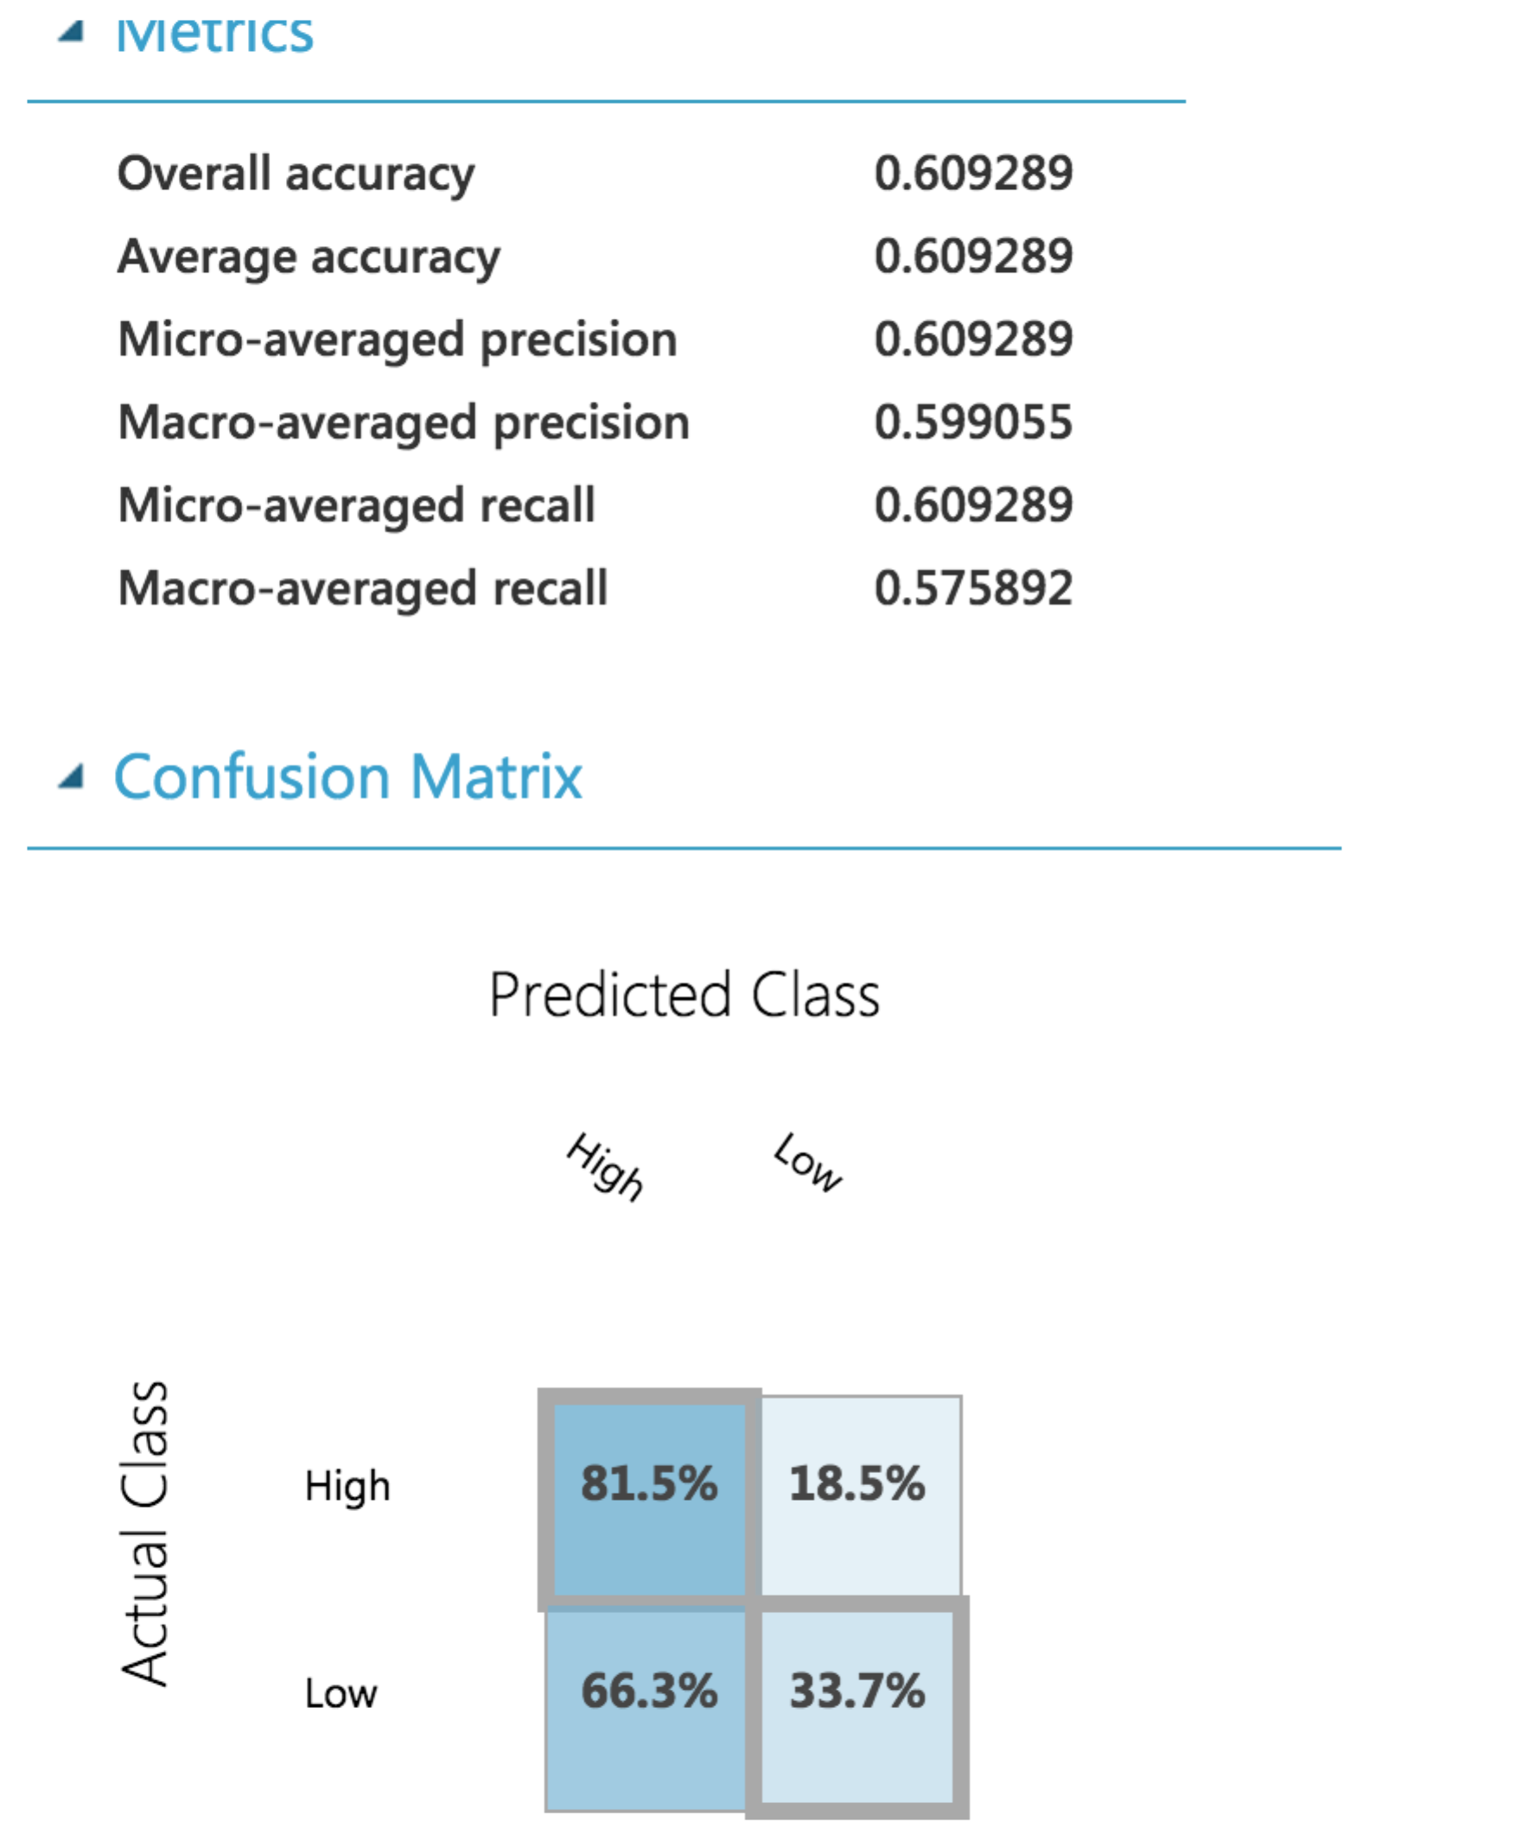

**ROC curve:**

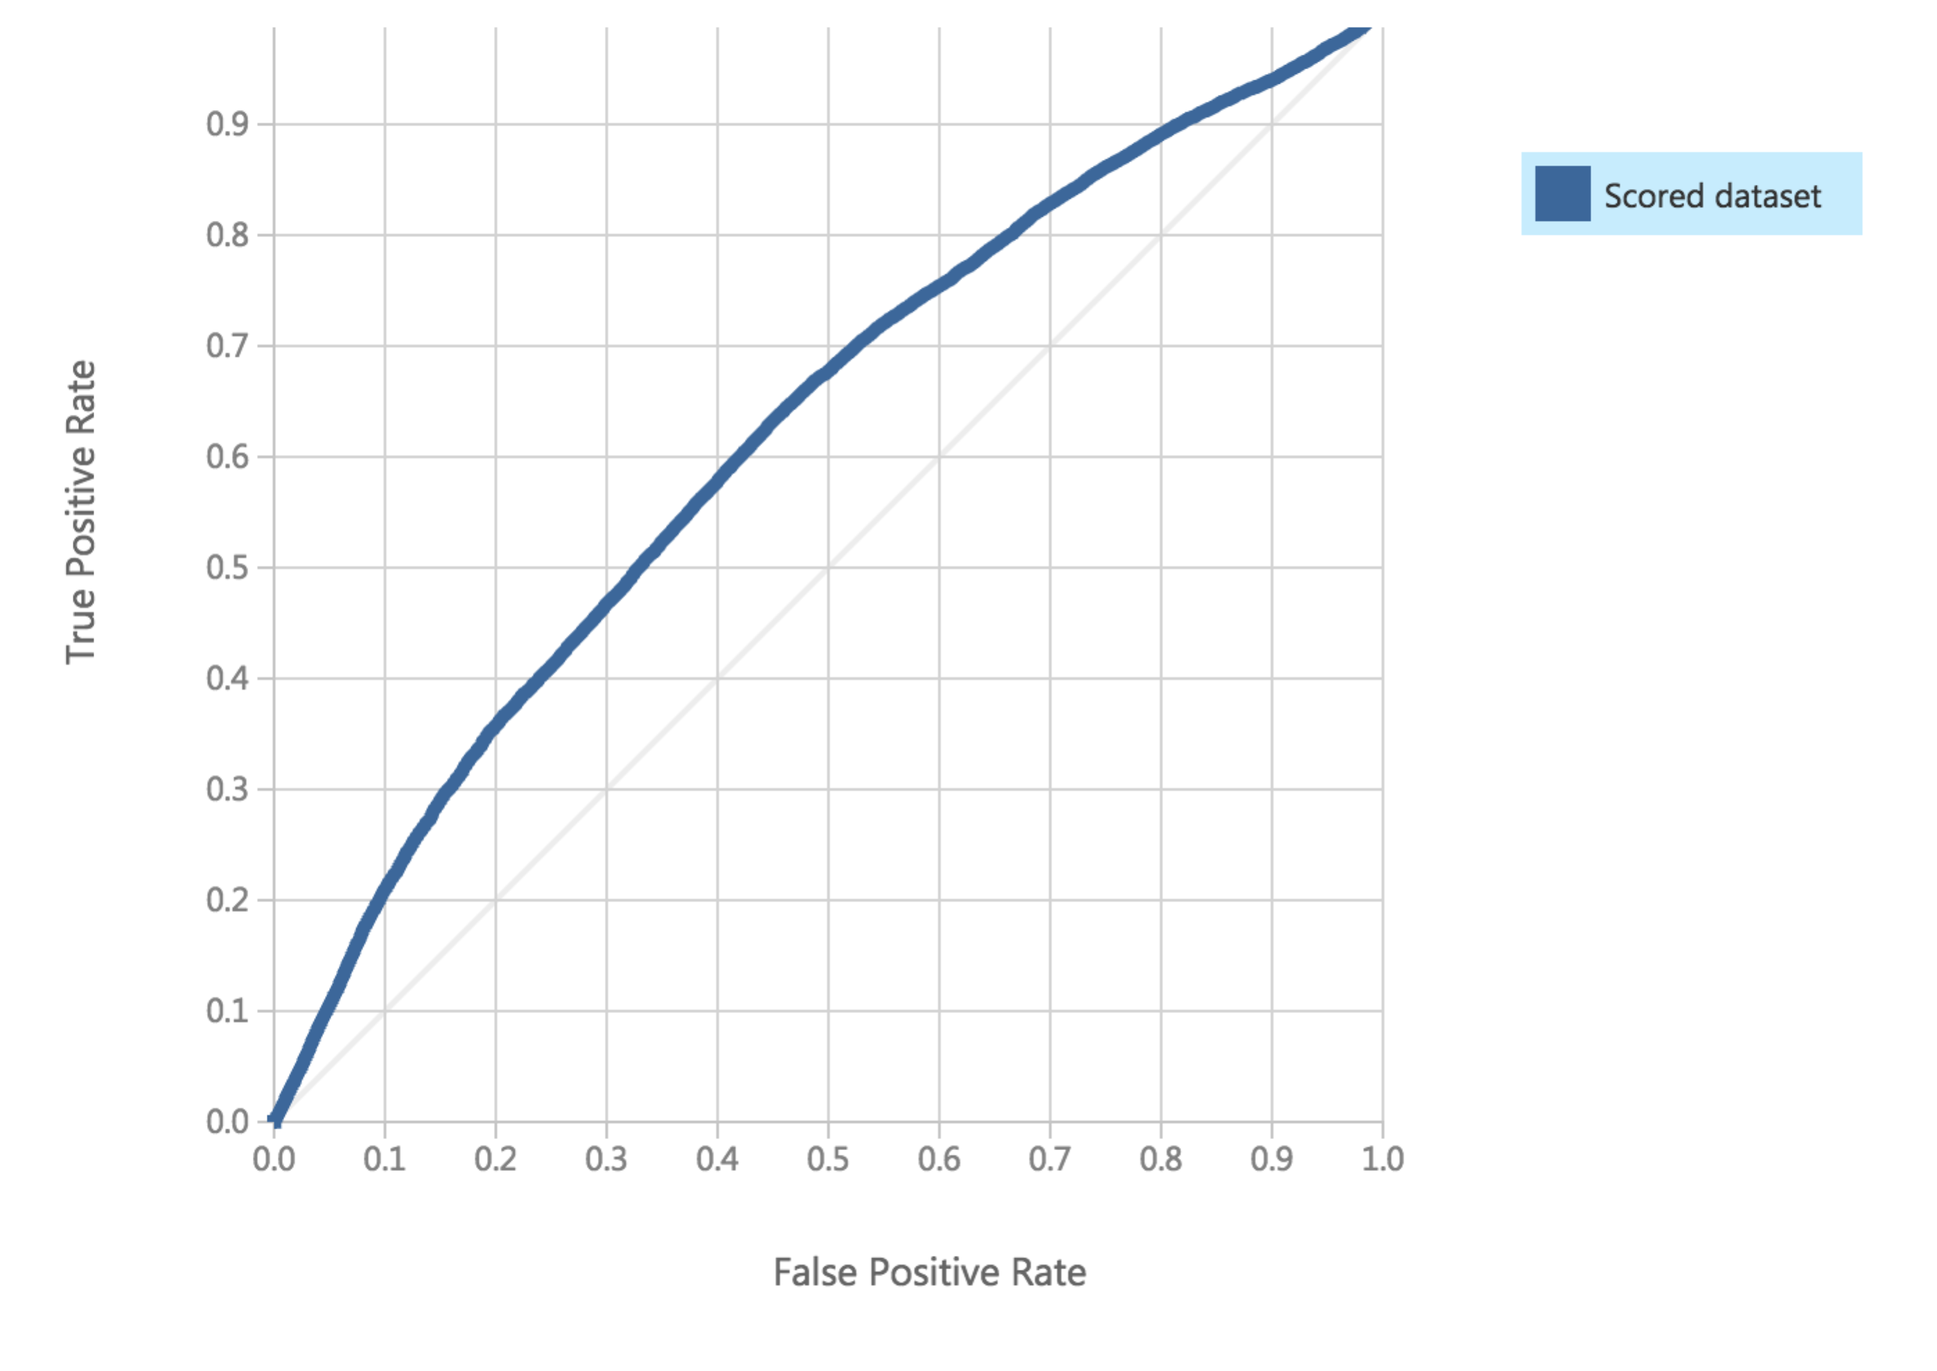

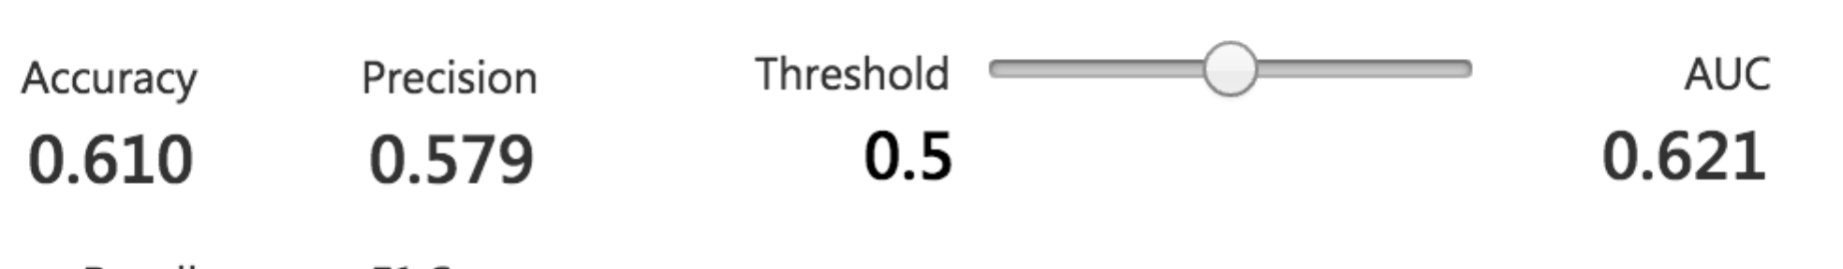

**Web-Service:**

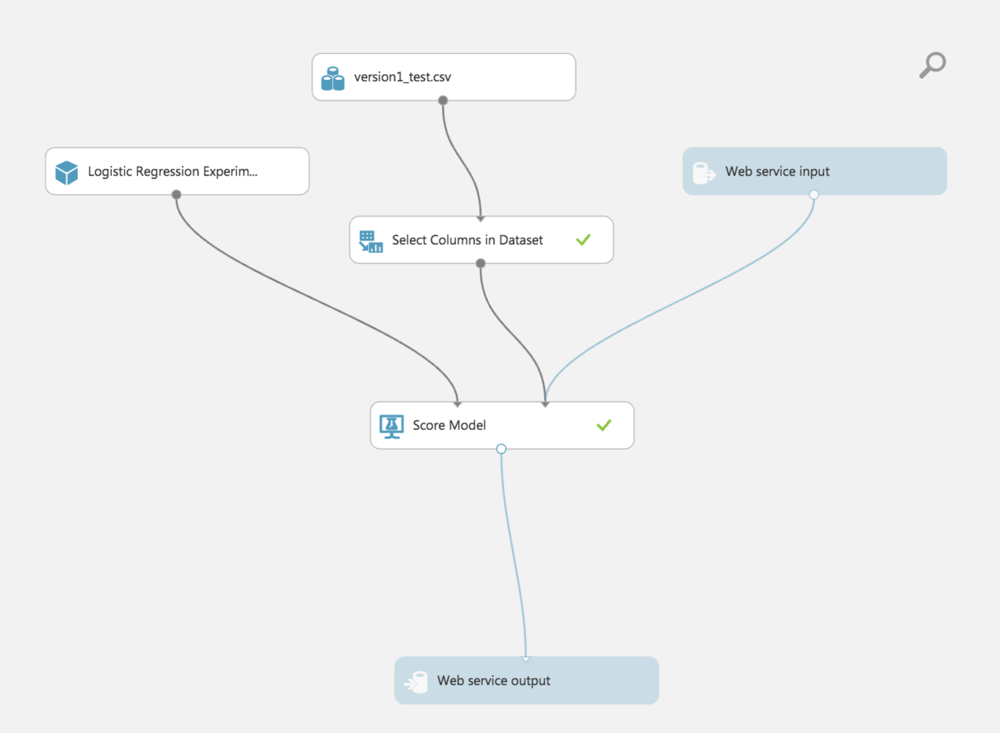

**Classification Model – Decision Forest**

The decision forest algorithm is an ensemble learning method for classification. The algorithm works by building multiple decision trees and then voting on the most popular output class. The aggregation process sums these histograms and normalizes the result to get the “probabilities” for each label. The trees that have high prediction confidence will have a greater weight in the final decision of the ensemble.

Advantages:

* They can represent non-linear decision boundaries.
* They are efficient in computation and memory usage during training and prediction.
* They perform integrated feature selection and classification.
* They are resilient in the presence of noisy features.

Disadvantages:

* May overfit data
* May get stuck in local minima so need ensembles to help reduce the variance

**Trained Model:**

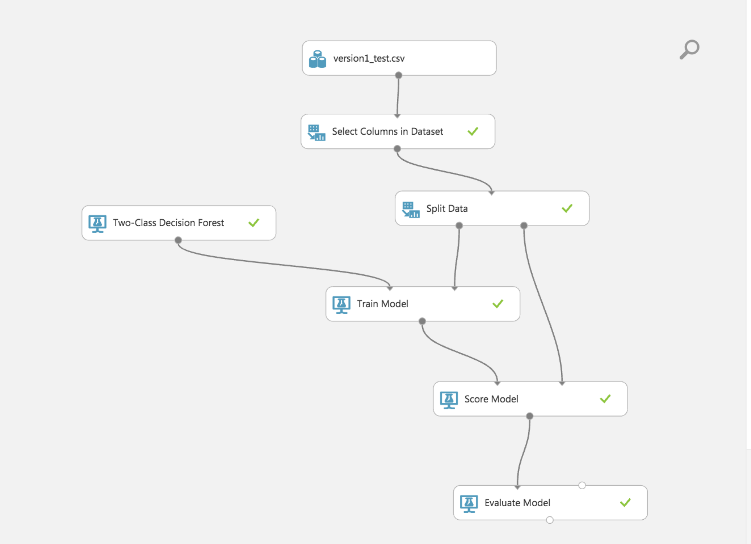

**Properties: Explained in Regression notes**

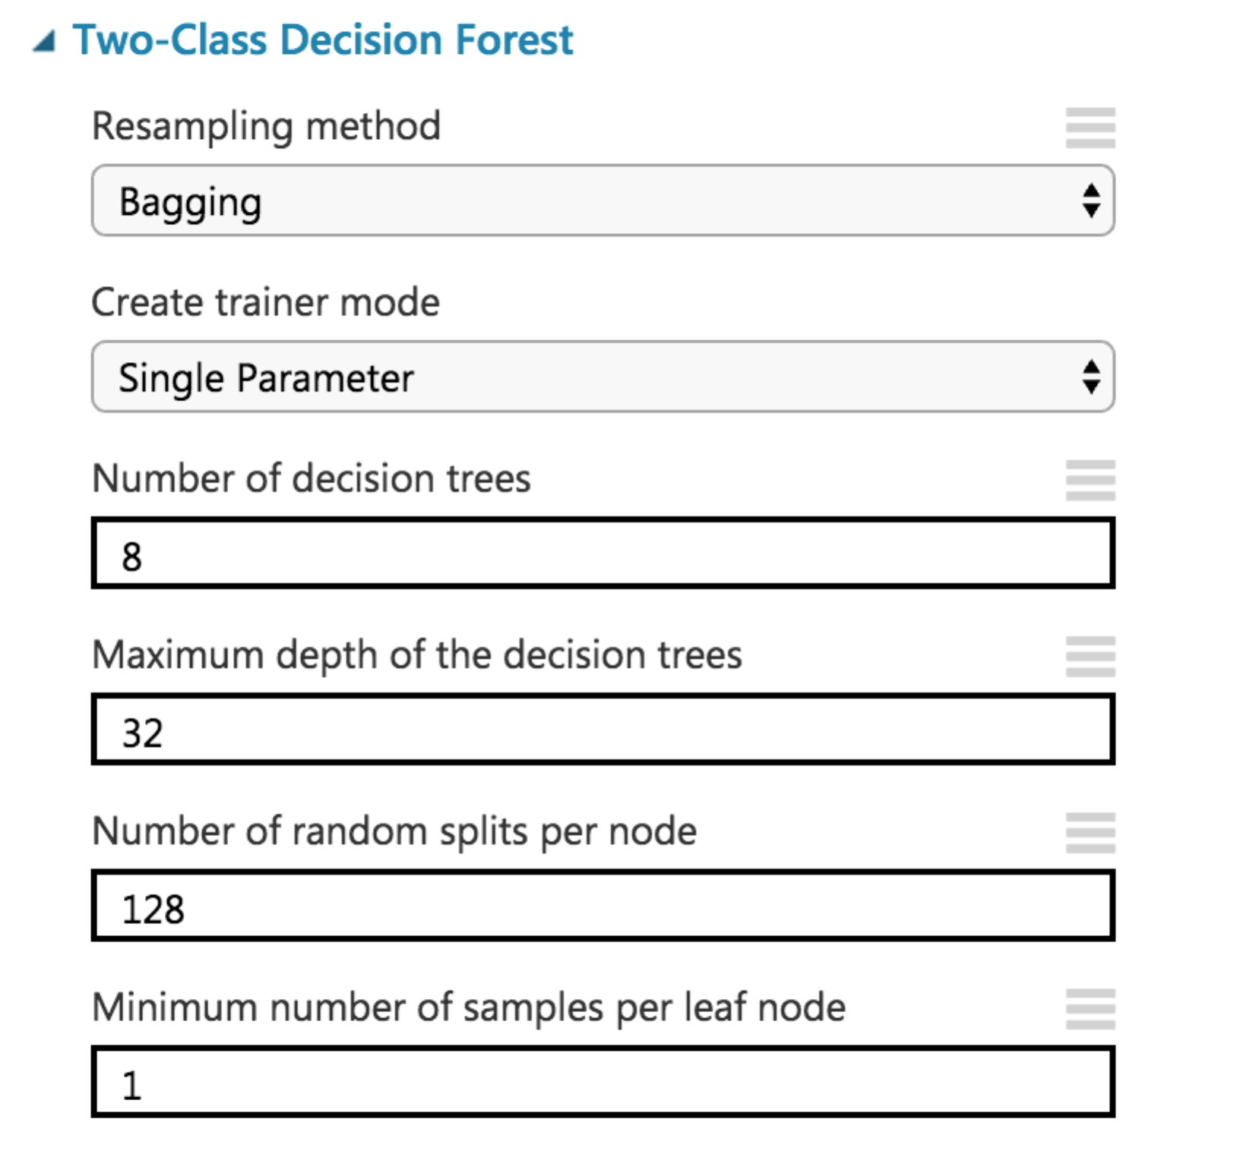

**Classification Results:**

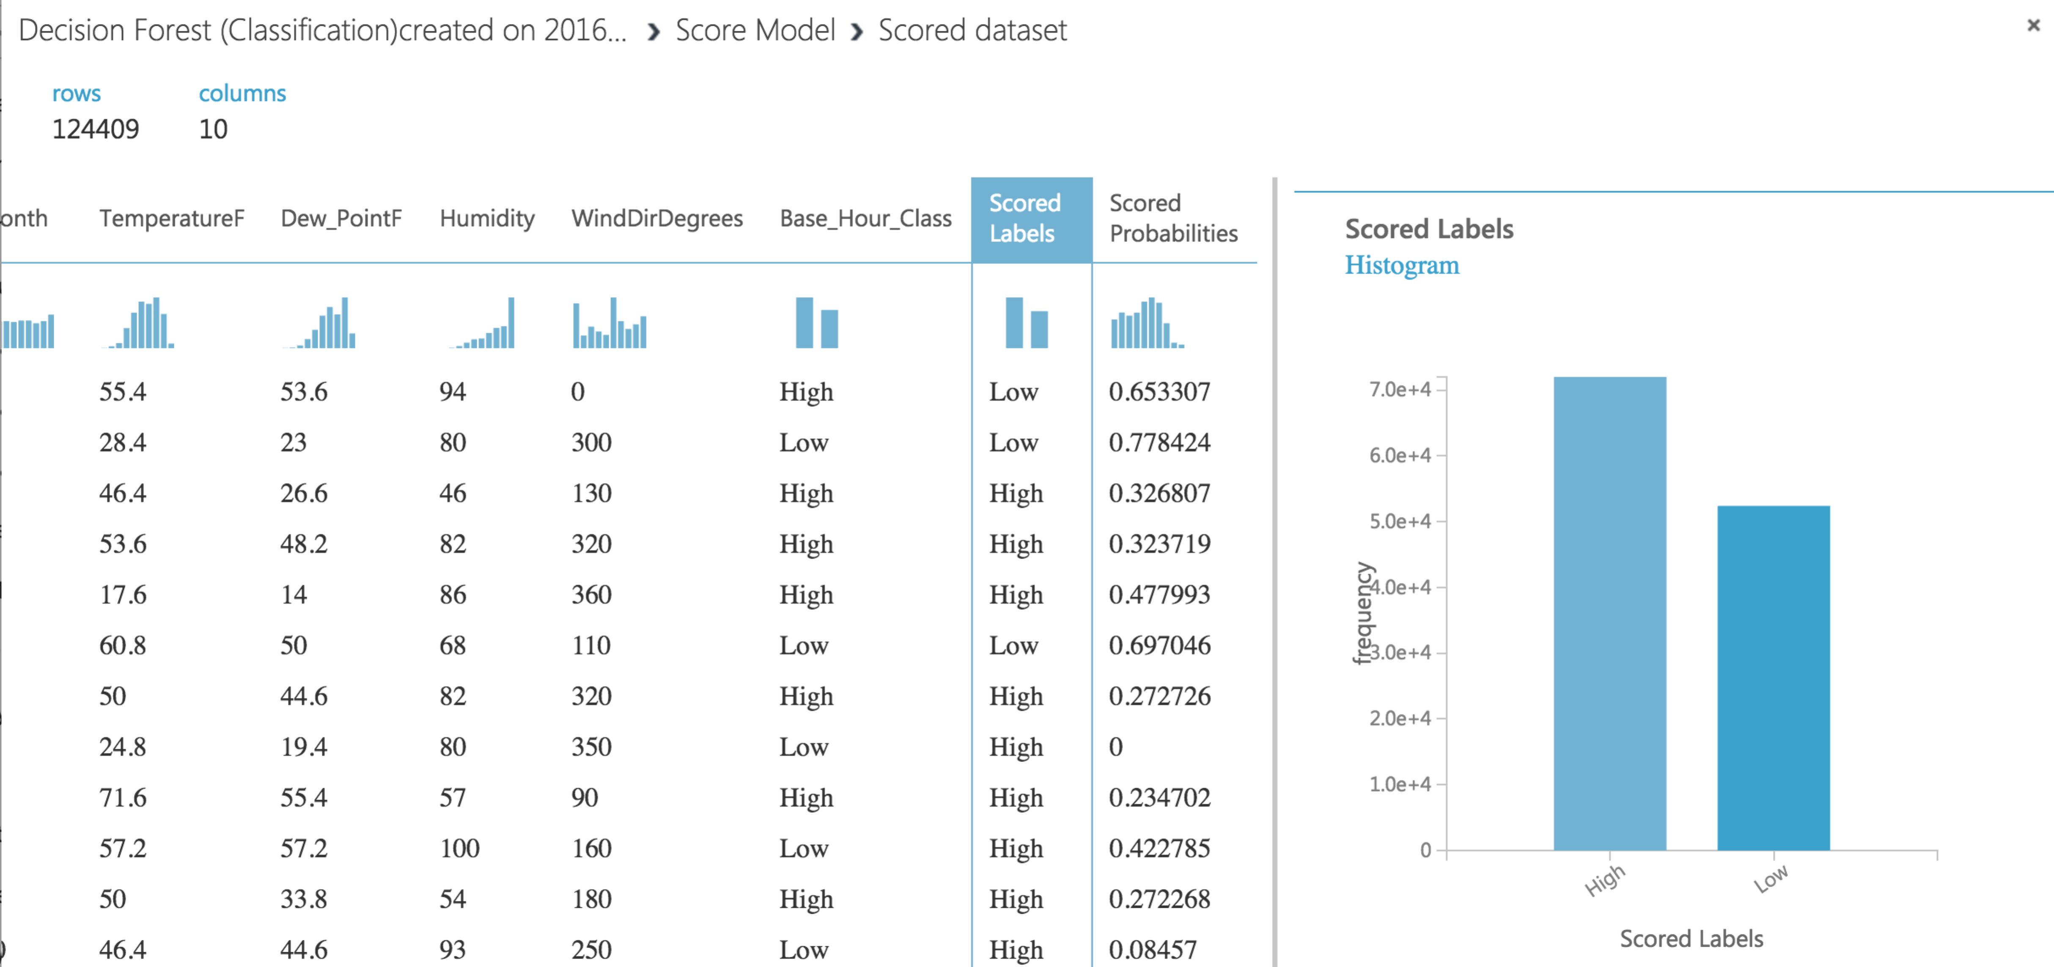

**Confusion matrix:**

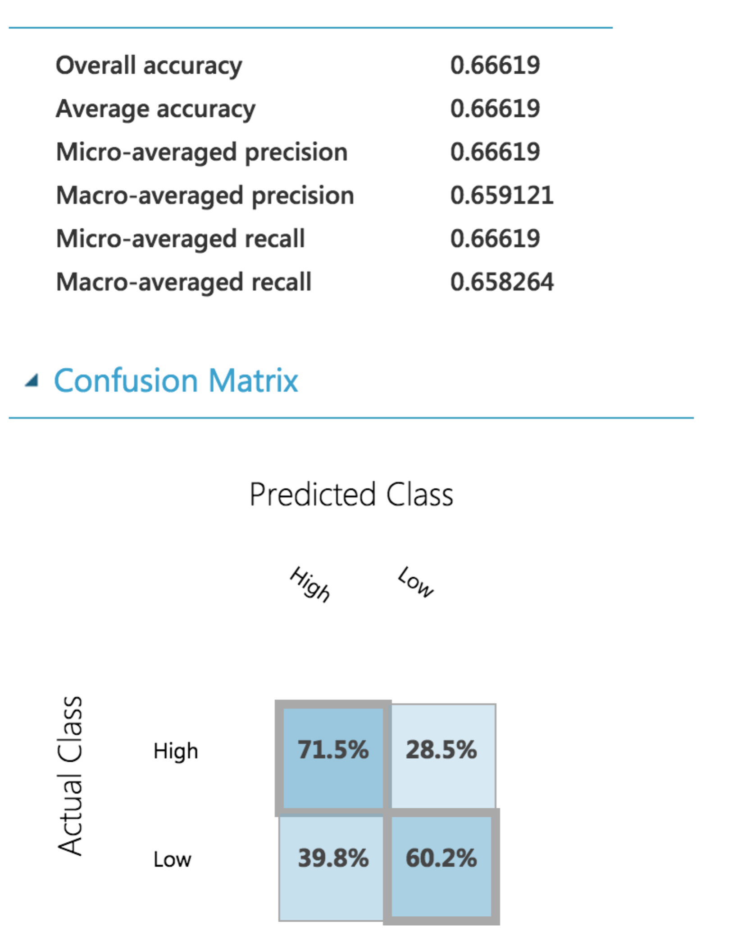

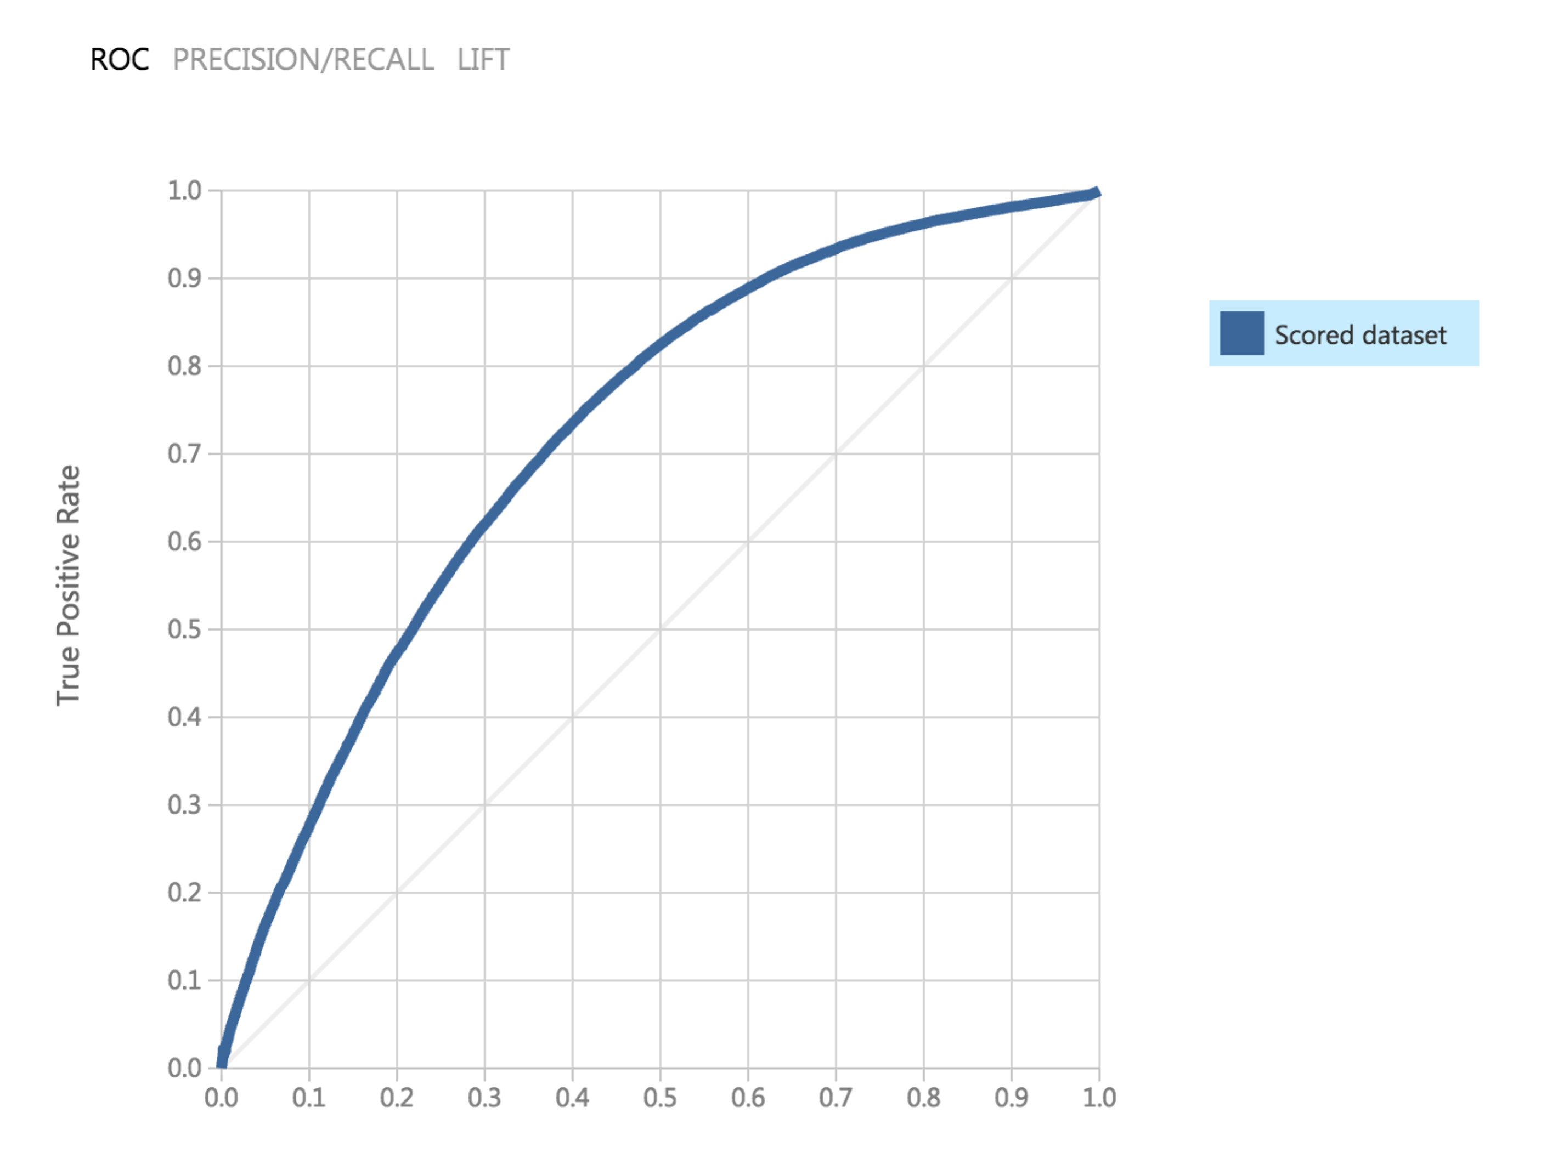

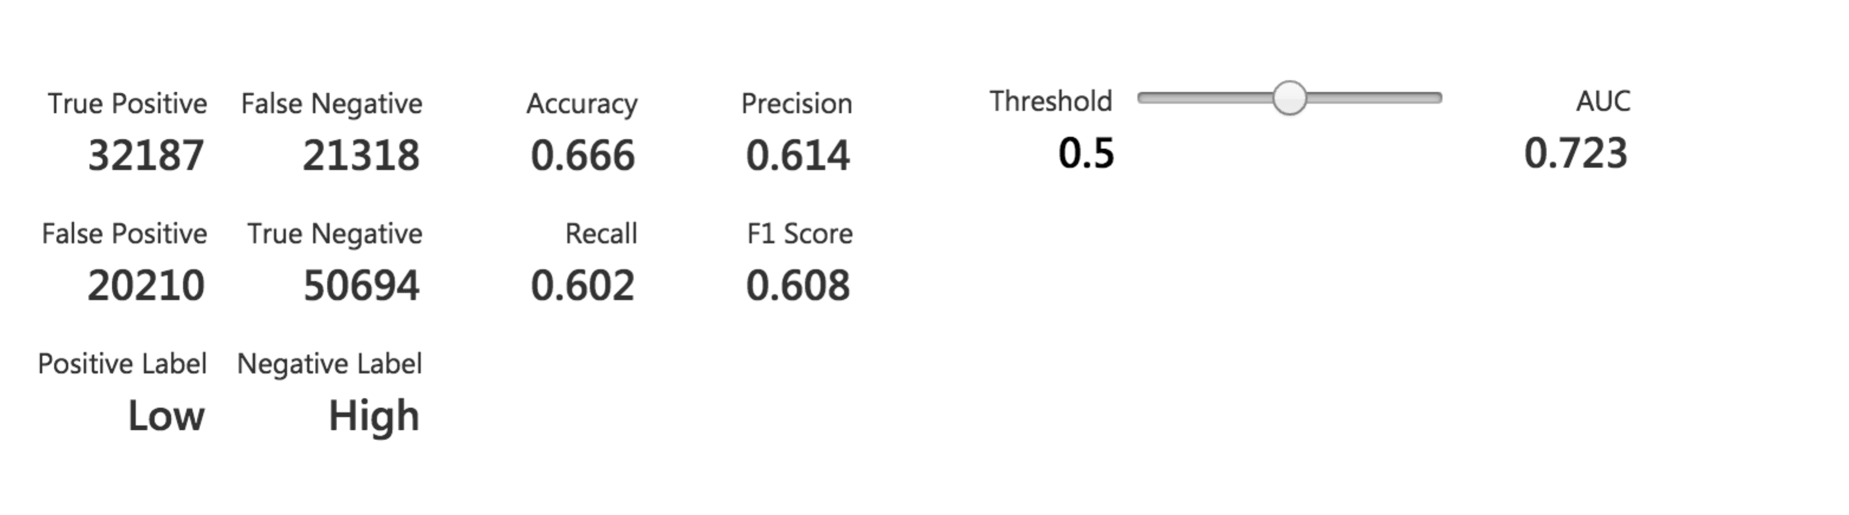

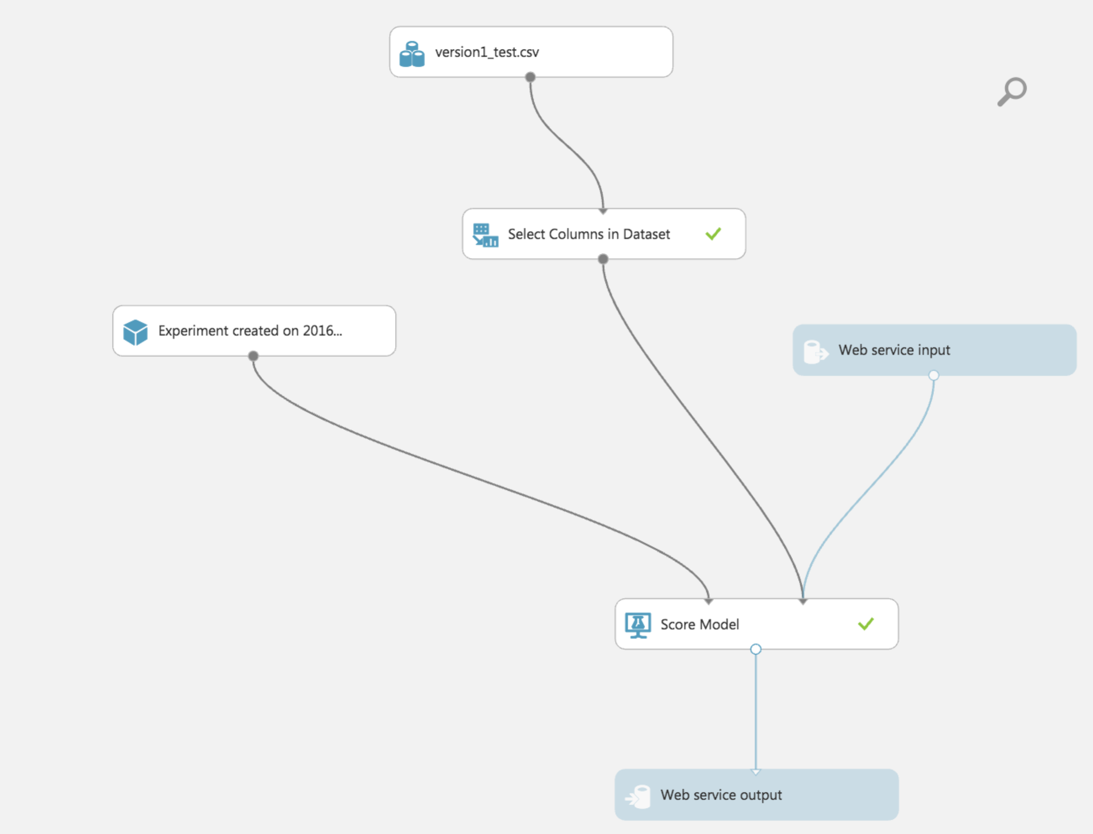

**Classification Model – K-Nearest Neighbor**

K nearest neighbors is a simple algorithm that stores all available cases and classifies new cases based on a similarity measure (e.g., distance functions). KNN has been used in statistical estimation and pattern recognition already in the beginning of 1970’s as a non-parametric technique.

A case is classified by a majority vote of its neighbors, with the case being assigned to the class most common amongst its K nearest neighbors measured by a distance function. If K = 1, then the case is simply assigned to the class of its nearest neighbor.

Drawback: One major drawback in calculating distance measures directly from the training set is in the case where variables have different measurement scales or there is a mixture of numerical and categorical variables.

Advantages:

* Robust to noisy training data
* Effective if the training data is large

Disadvantages:

* Need to determine value of parameter K
* Distance based learning is not clear which type of distance to use and which attribute to use to produce the best results
* Computation cost is high

**Trained model:**

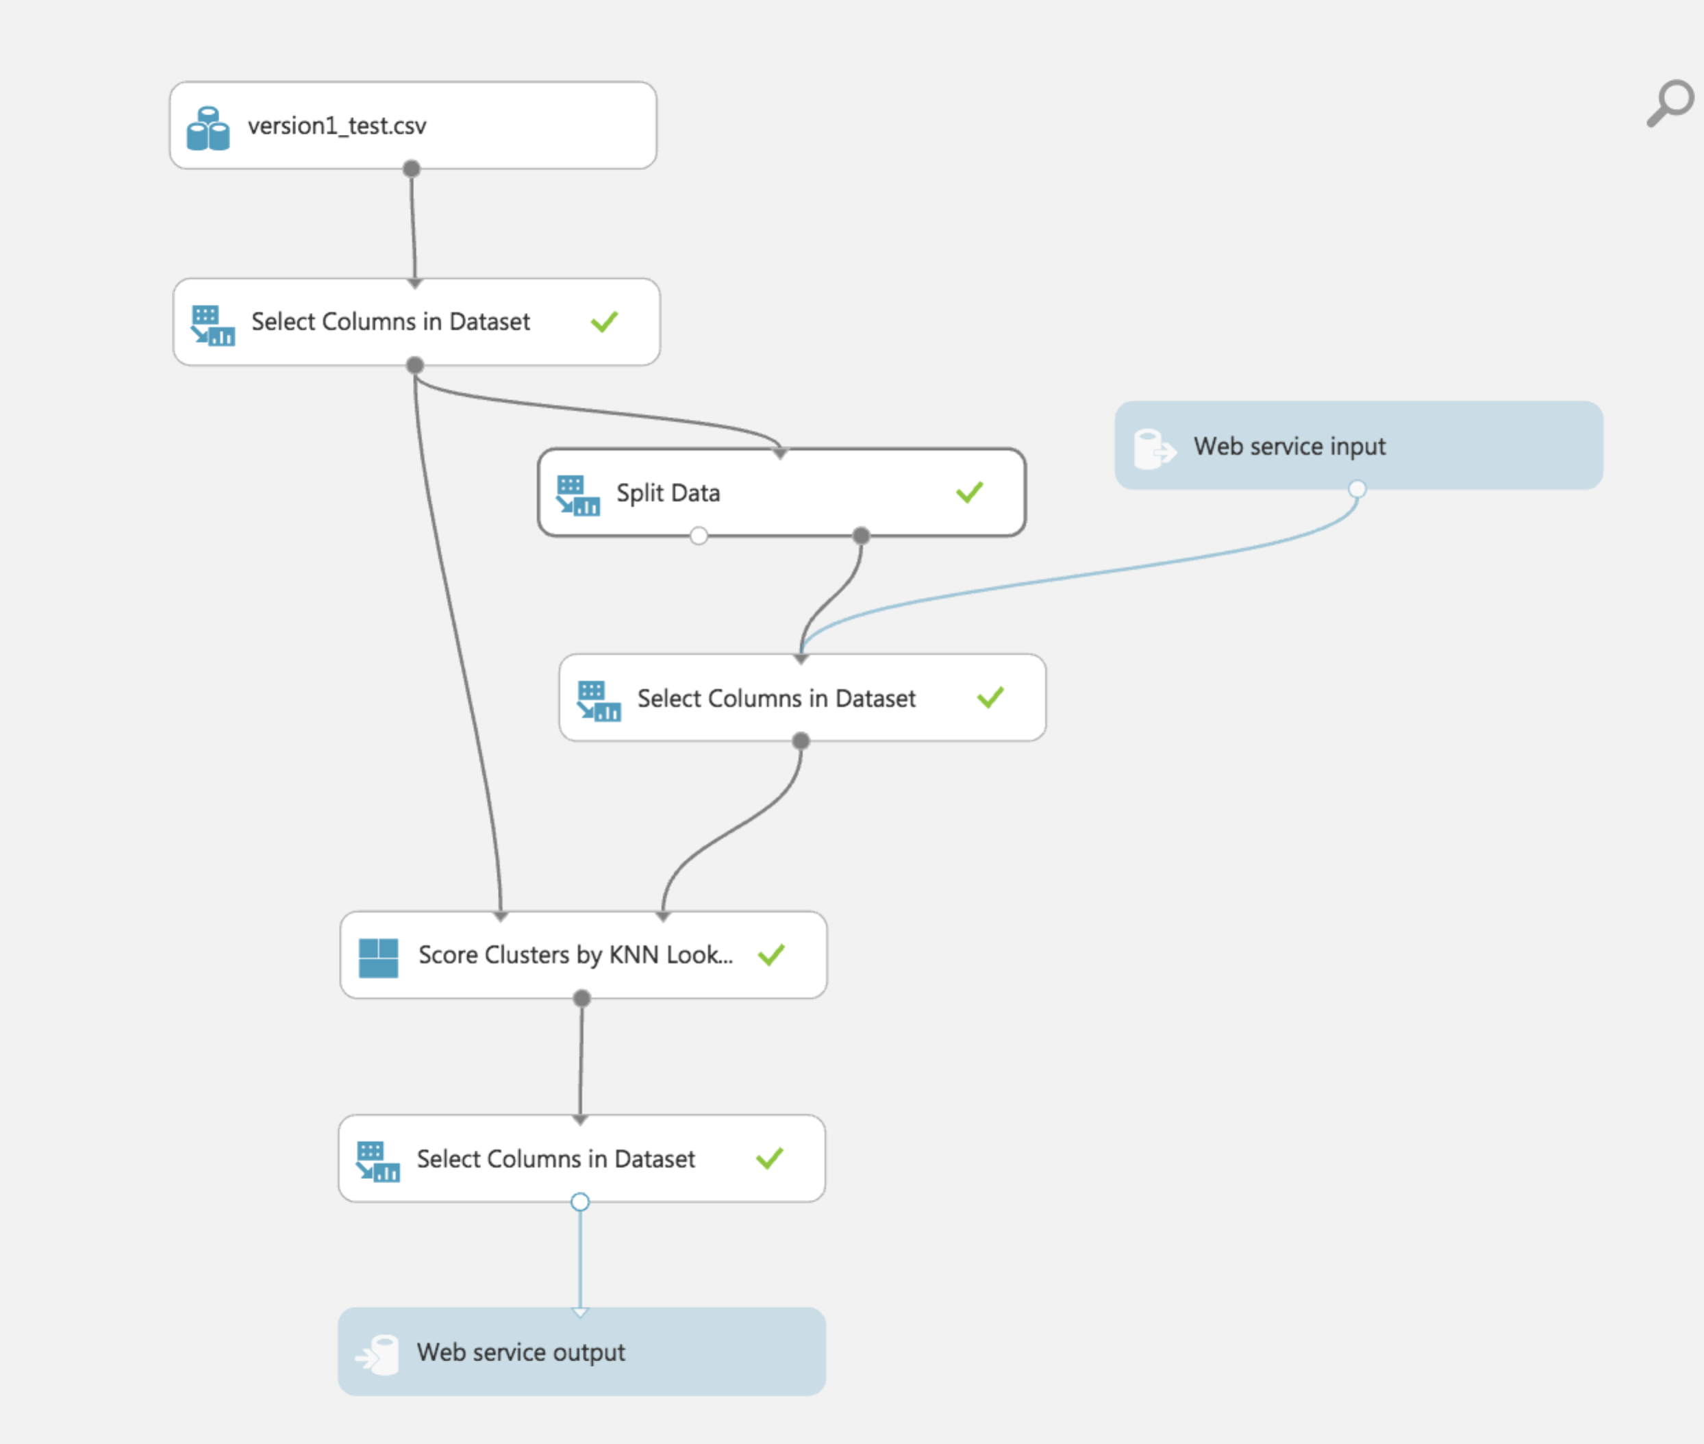

**Classification Results:**

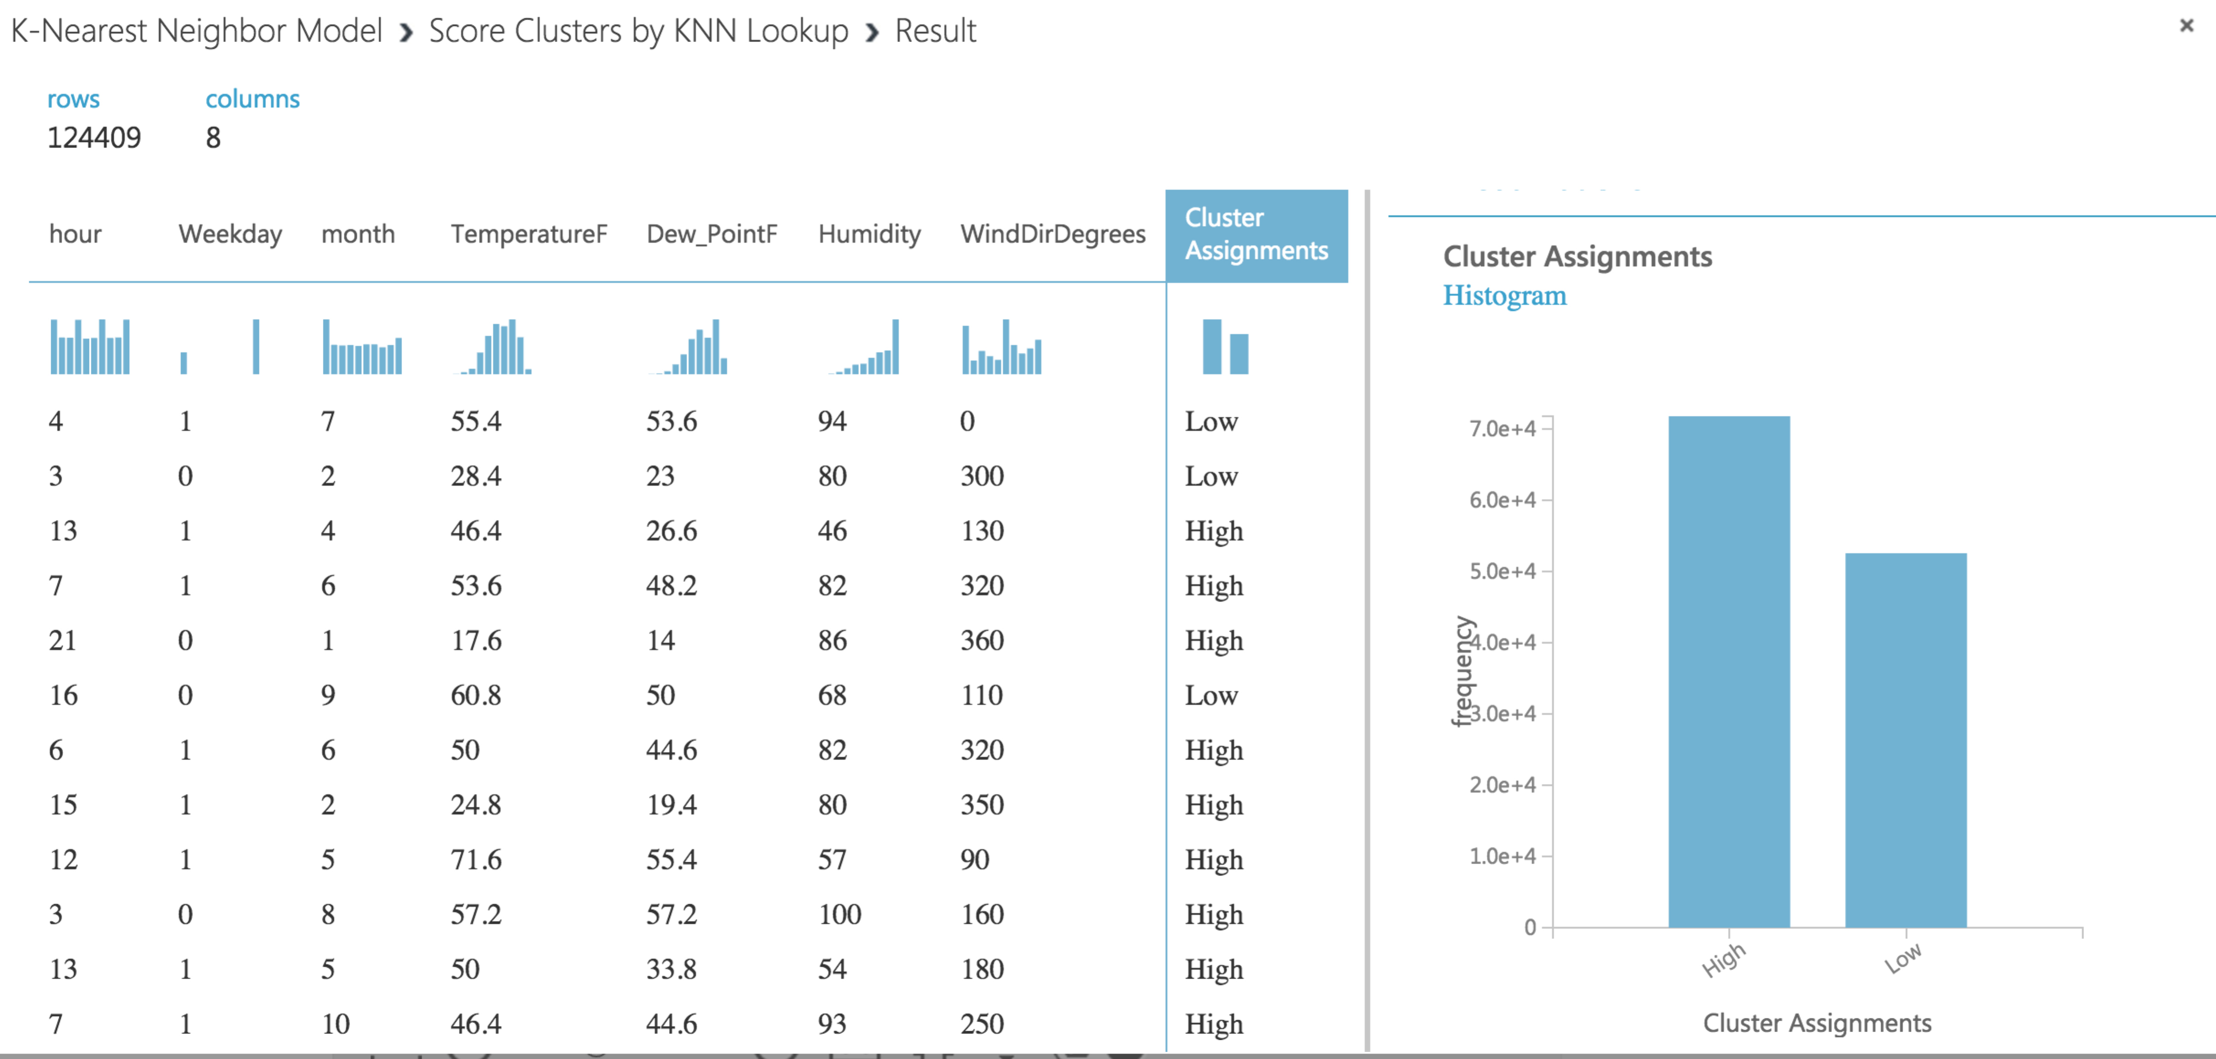

**Classification Model – Neural Network**

A neural network is a set of interconnected layers, in which the inputs lead to outputs by a series of weighted edges and nodes. The weights on the edges are learned when training the neural network on the input data. The direction of the graph proceeds from the inputs through the hidden layer, with all nodes of the graph connected by the weighted edges to nodes in the next layer.

To compute the output of the network for any given input, a value is calculated for each node in the hidden layers and in the output layer. For each node, the value is set by calculating the weighted sum of the values of the nodes in the previous layer and applying an activation function to that weighted sum.

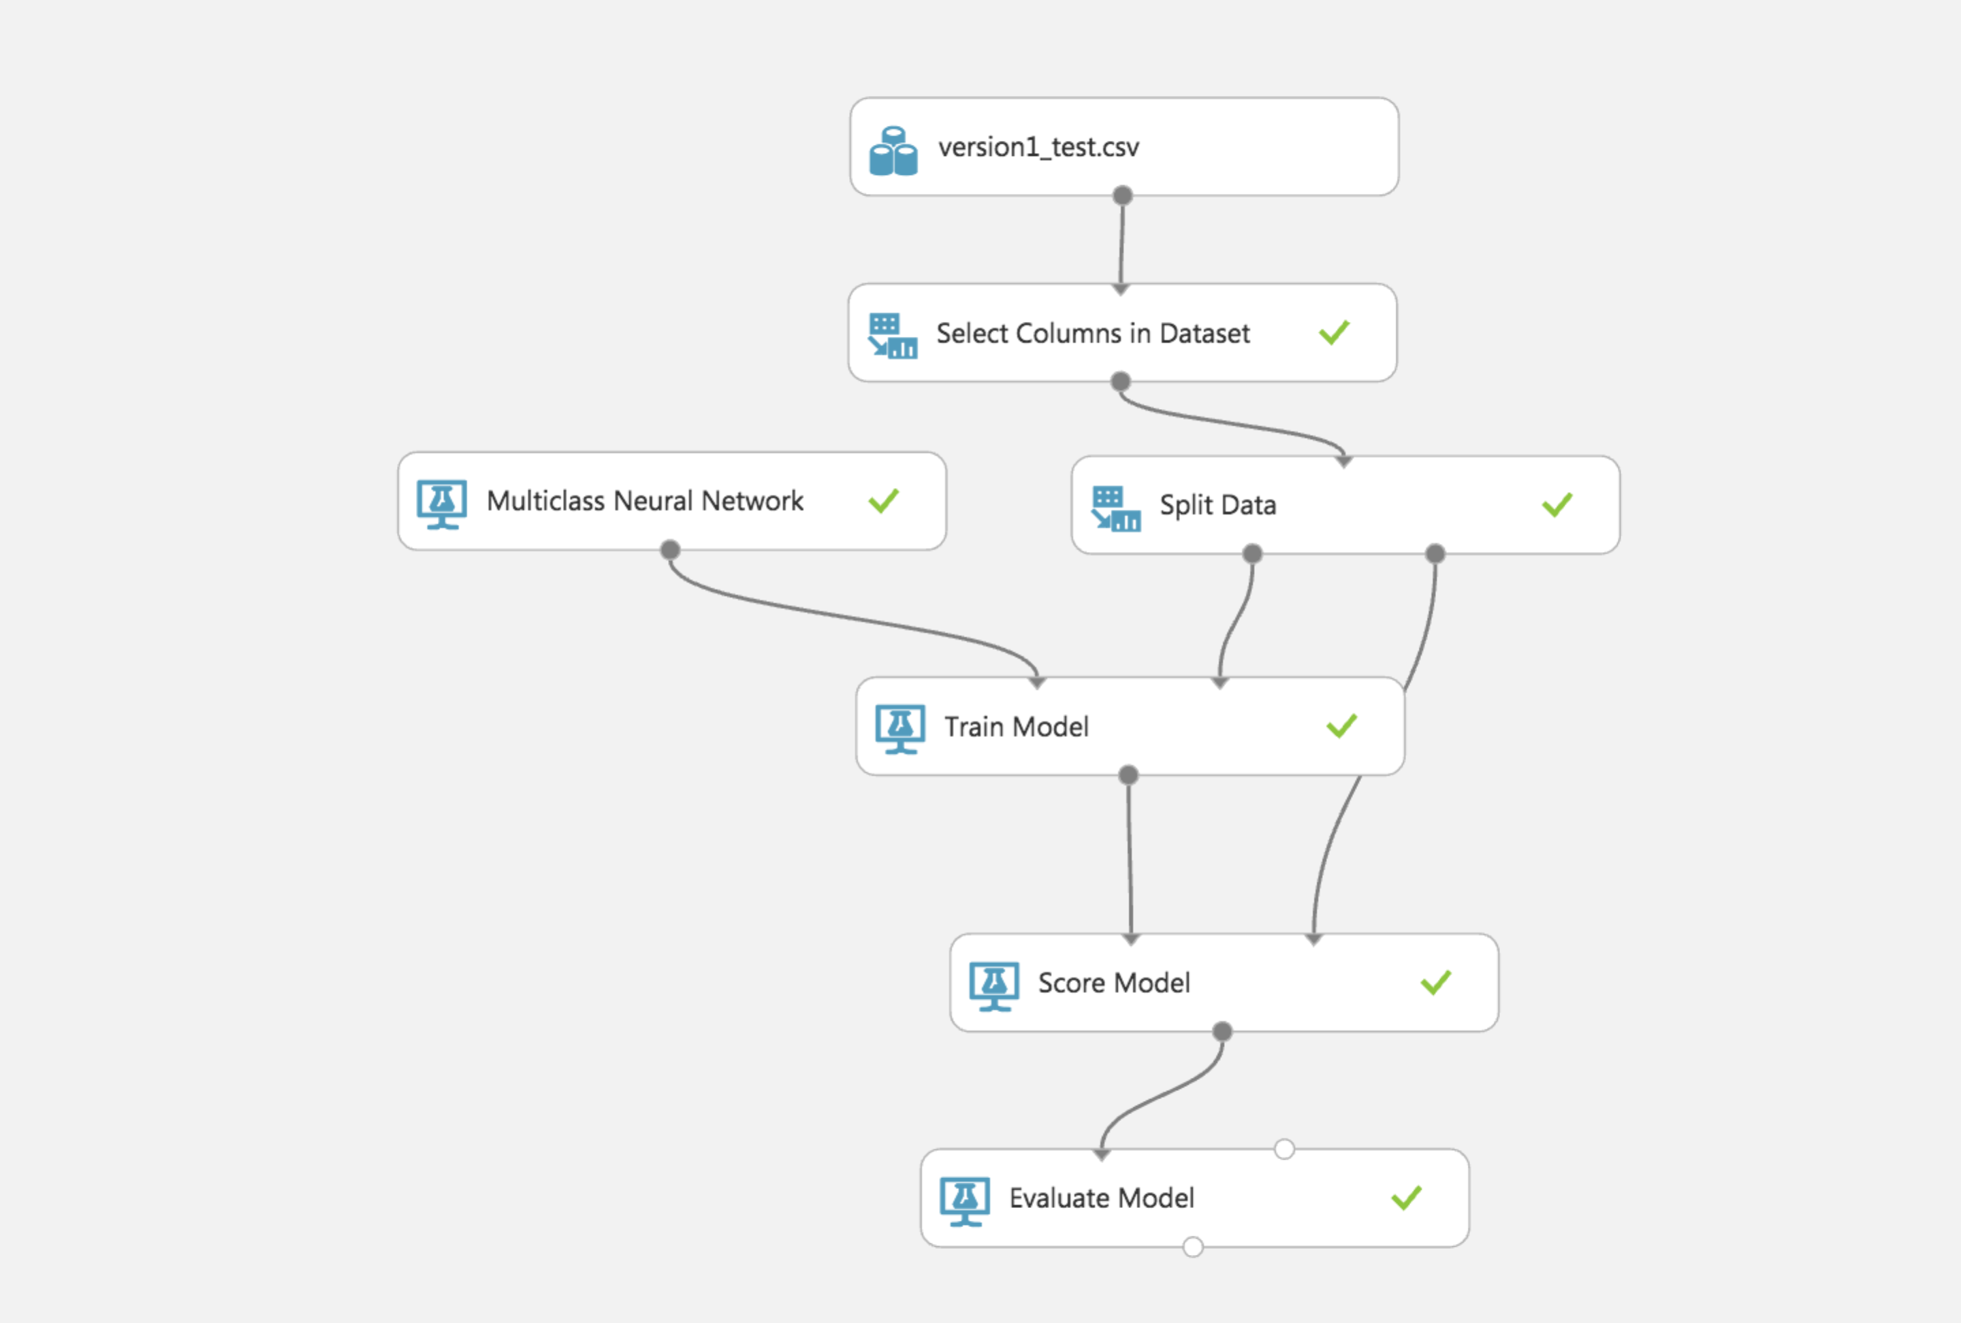

**Properties:**

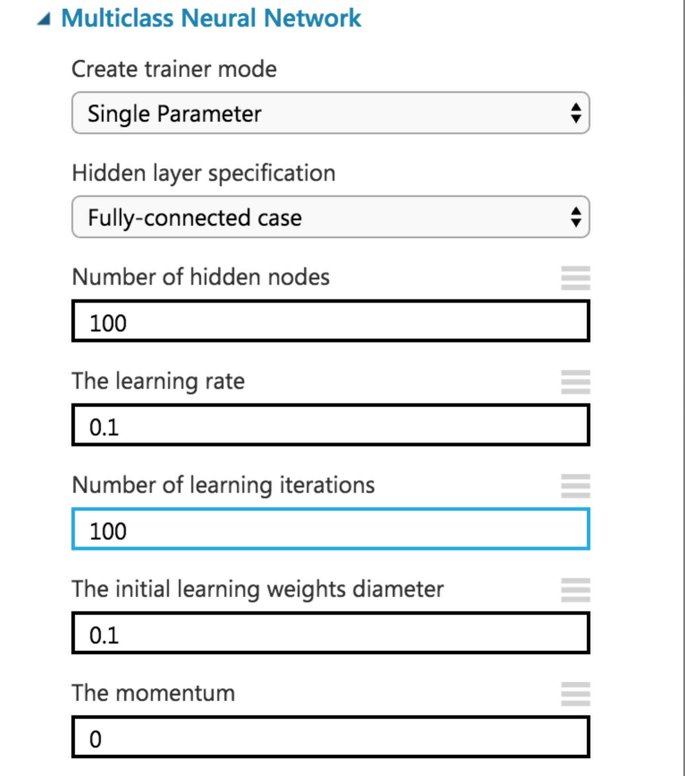

**Classification Results:**

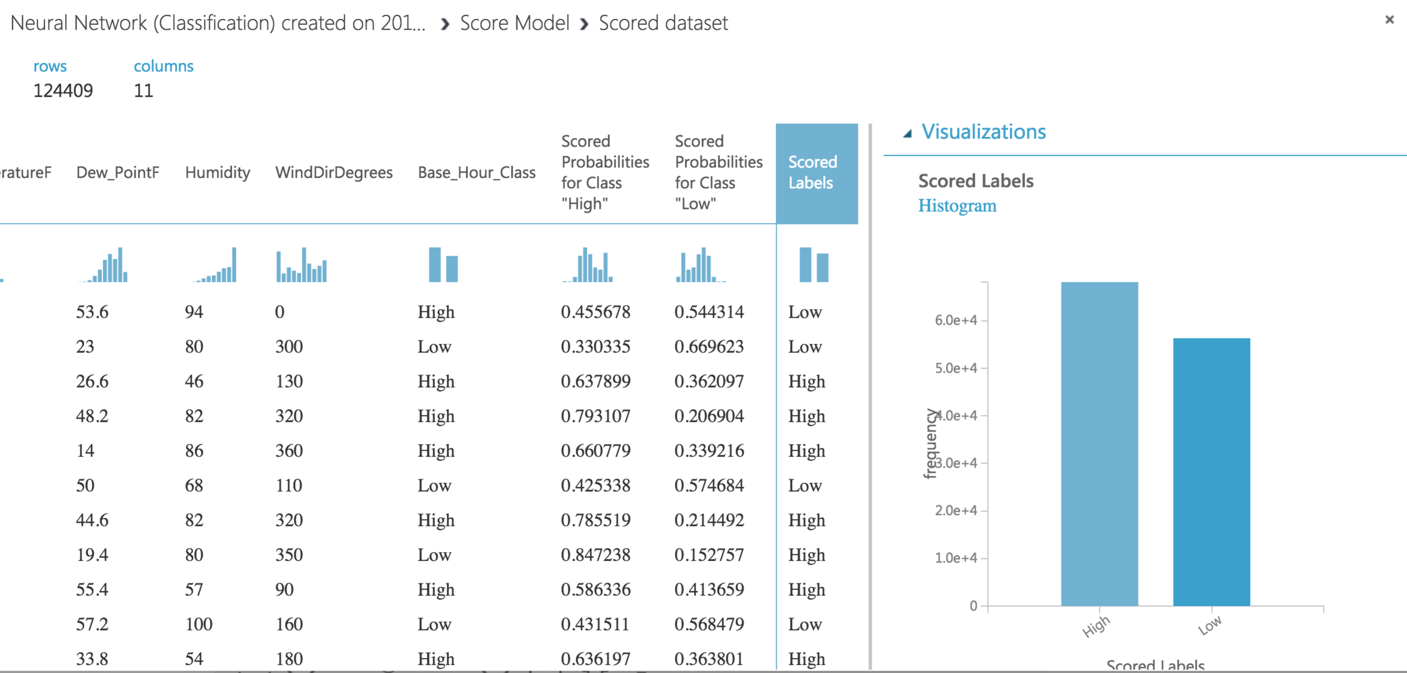

**Performance Metric:**

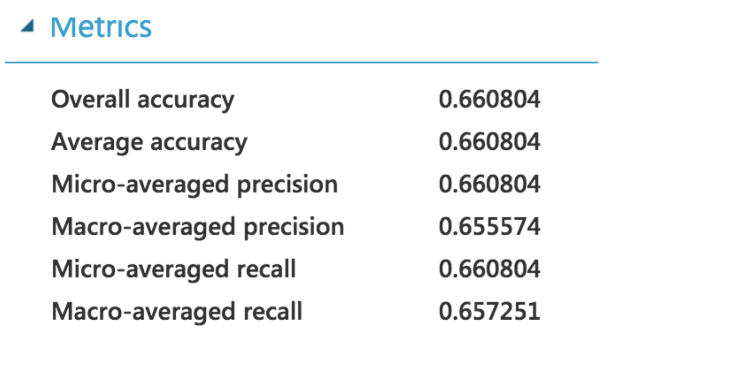

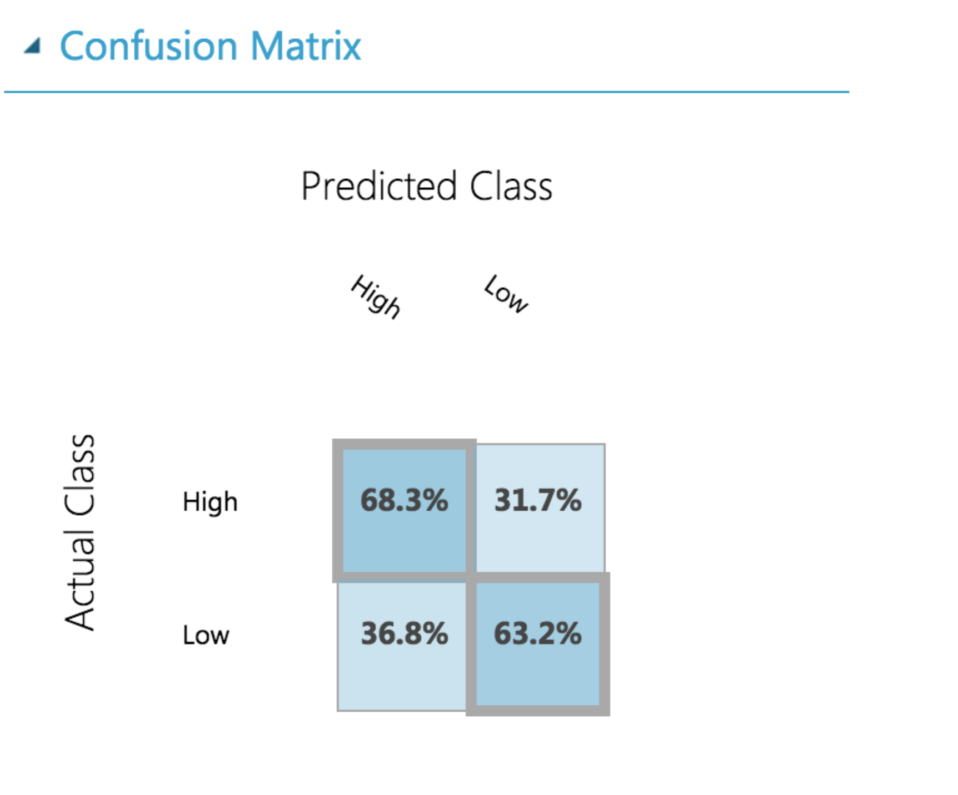

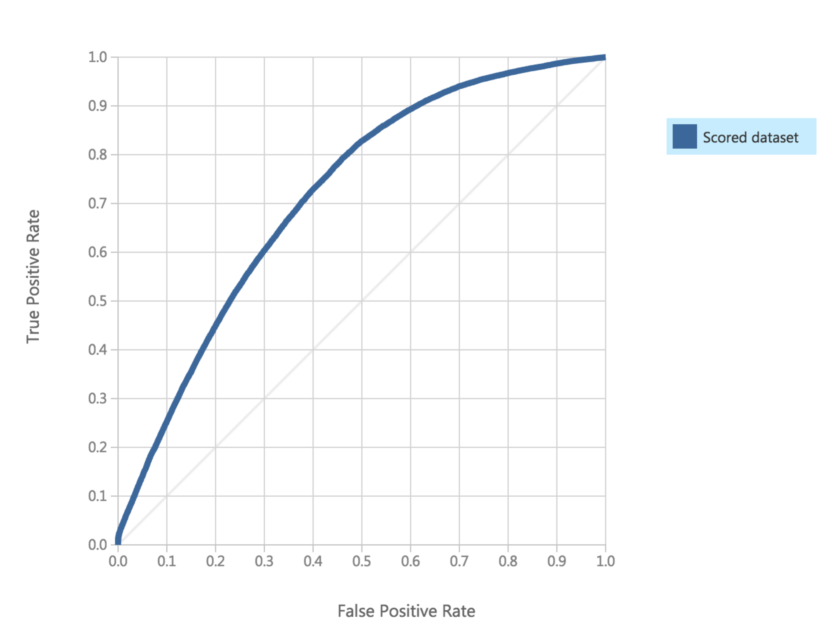

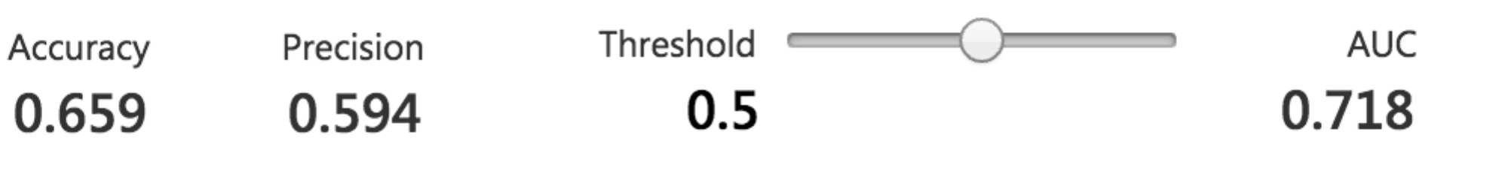

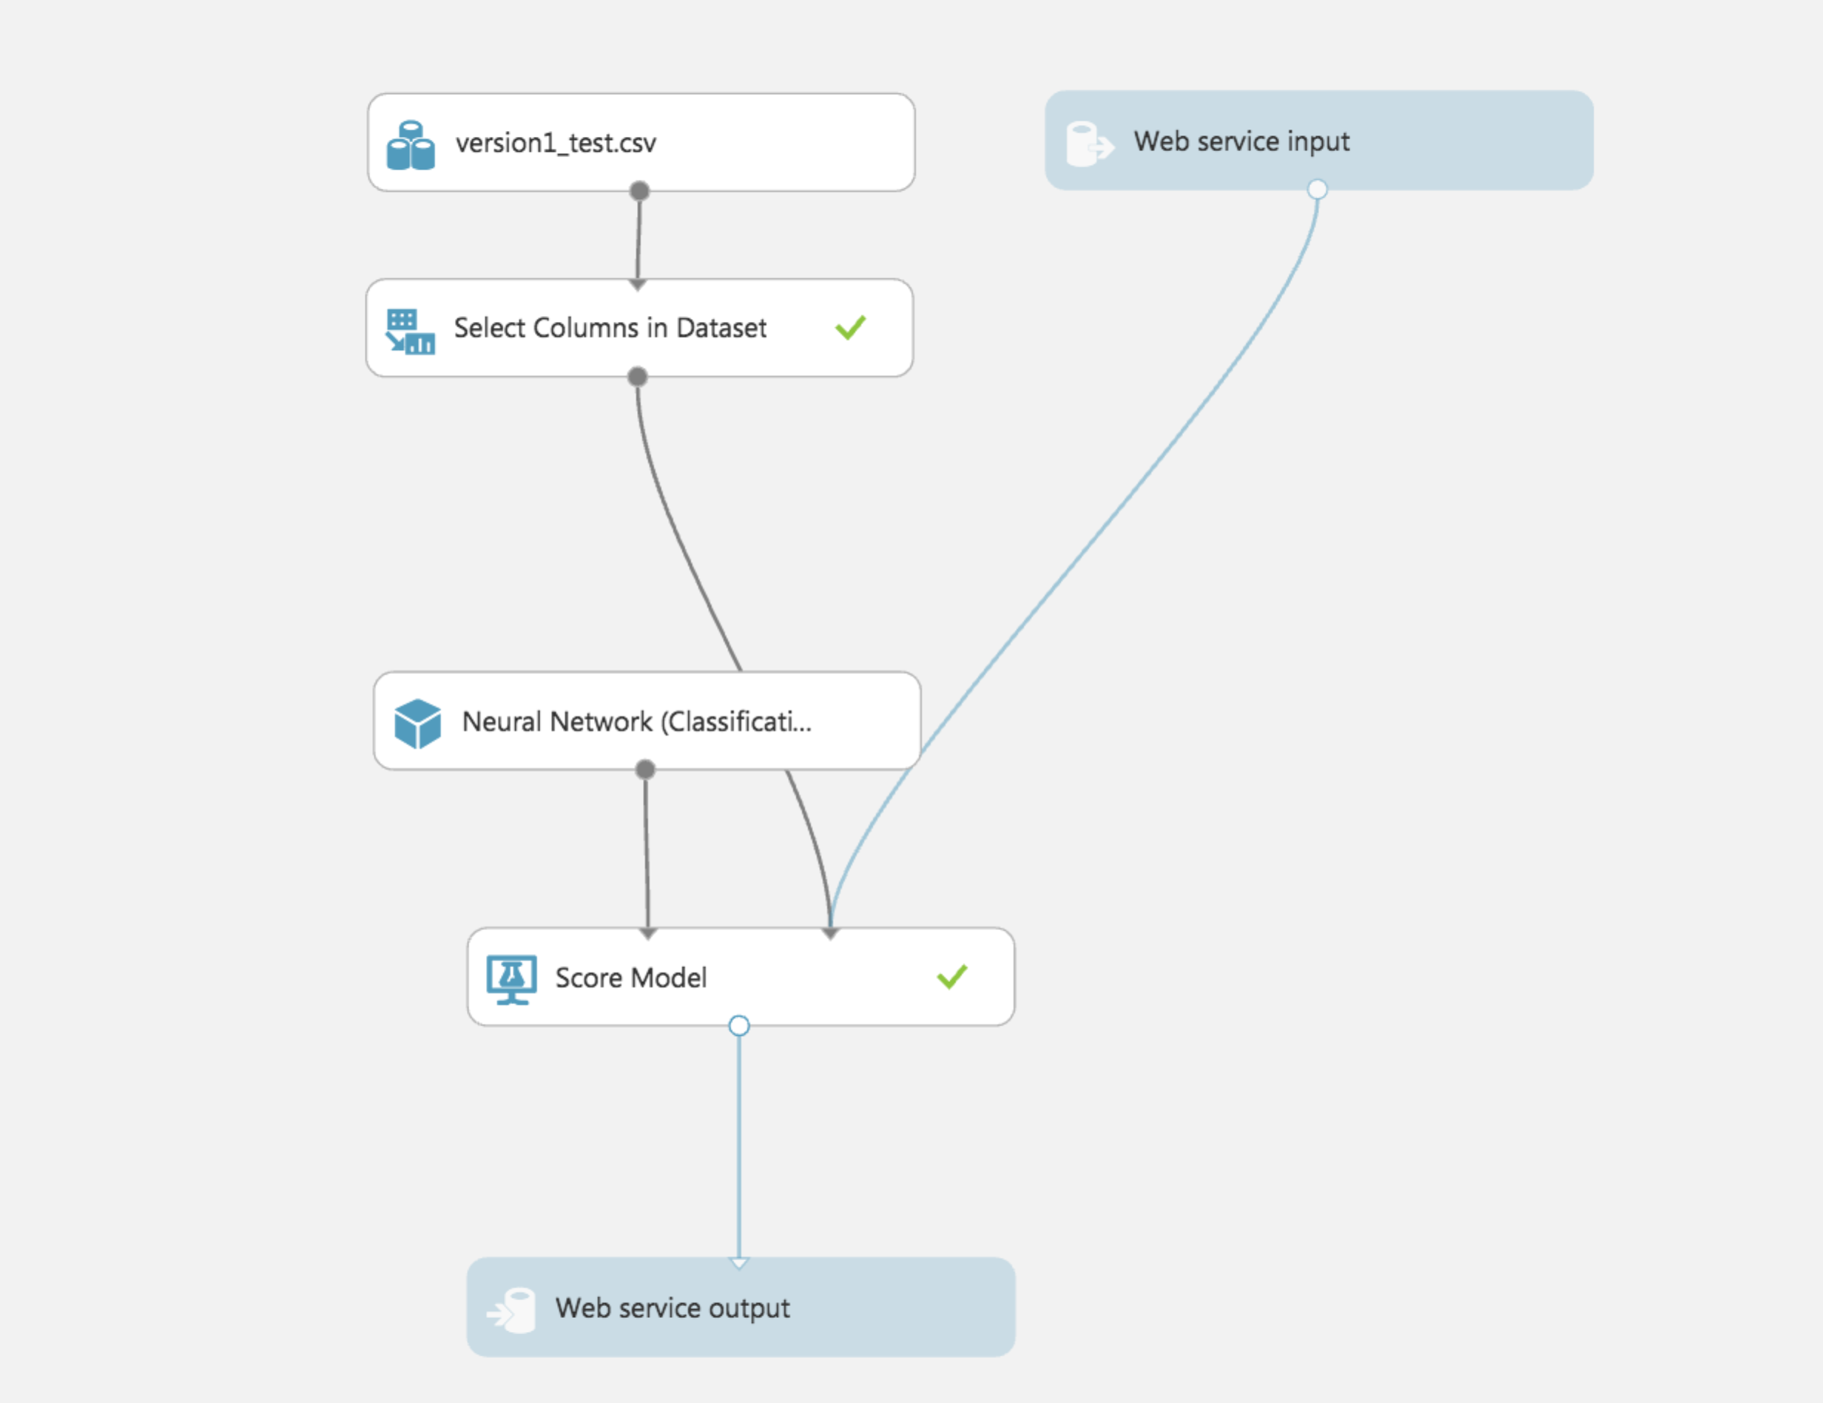

|  |  |
| --- | --- |
| **Model** | **Performance Metrics** |
| 1. **Logistic Regression** |  |
| 1. **Decision Forest** |  |
| 1. **Neural Network** |  |

**Result: The model with maximum accuracy is Decision Forest and it has the highest AUC, 71.8%**

# Clustering Modeling

Tools Used: Microsoft Azure ML Studio

**Building the K-Mean and Hierarchical Clustering Model**

Steps (K-Mean Model):

1. Upload the data.csv into Datasets of Azure Machine Learning Studio.
2. Input data from My Datasets
3. Select Columns from Dataset which are “meternumb”, “Consumption”, “area_floor._m.sqr”, “BuildingID”, “type”.
4. Using SQL code to Avg each column to make sure each column has same row.
5. Edit Metadata which change the type of column “type” to categorical.
6. Convert to indicator values about ‘type’ and make elect and dist_heating to 1 and 0; and then normalize data.
7. Select new columns for model use which are: “meternumb”, “area_floor._m.sqr”, “Comsumption”, “type-Dist_Heating”, “type-elect” without “type”.
8. Use K-Mean Clustering of Azure Machine Learning Studio to train the model, based on the algorithm.
9. From train clustering model we can see two cluster which is 0 and 1.
10. Select Column again which include new column which called “Assignments” and present in 0 and 1.
11. Score the model in cluster by KNN to get “Cluster Assignments”.
12. Select “Cluster Assignments” and Evaluate the model.

**K-Means Clustering:**

Clustering uses iterative techniques to group cases in a dataset into clusters that contain similar characteristics. These groupings are useful for exploring data, identifying anomalies in the data, and eventually for making predictions. Clustering models also can help you identify relationships in a dataset that you might not logically derive by browsing or simple observation.

* **First N**. Some initial number of data points are chosen from the data set and used as the initial means.
  + Also called the Forgy method.
* **Random**. The algorithm randomly places a data point in a cluster and then computes the initial mean to be the centroid of the cluster's randomly assigned points.

Also called the random partition method.

* **K-Means++**. This is the default method for initializing clusters.

The **K-means ++** algorithm was proposed in 2007 by David Arthur and Sergei Vassilvitskii to avoid poor clustering by the standard k-means algorithm. **K-means ++** improves upon standard K-means by using a different method for choosing the initial cluster centers.

* **K-Means++Fast**. A variant of the **K-means ++** algorithm that was optimized for faster clustering.
* **Evenly**. Centroids are located equidistant from each other in the d-Dimensional space of n data points.
* **Use label column**. The values in the label column are used to guide the selection of centroids.

**Advantages:**

* Faster, because order of time complexity is linear with the number of data
* Works great if clusters are spherical
* Simple, easy to implement

**Disadvantages:**

* Different densities may work poorly with clusters with different densities but spherical shape.
* Sensitive to outliers

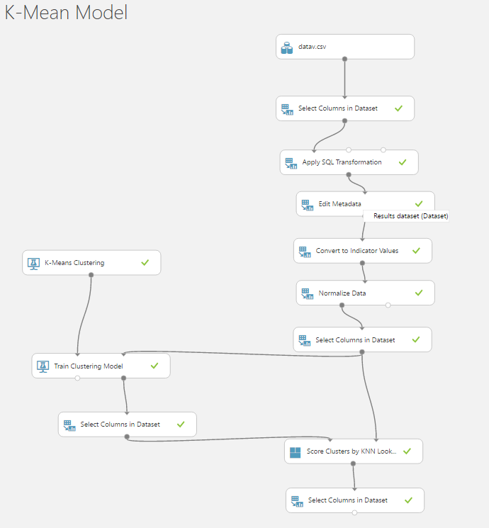

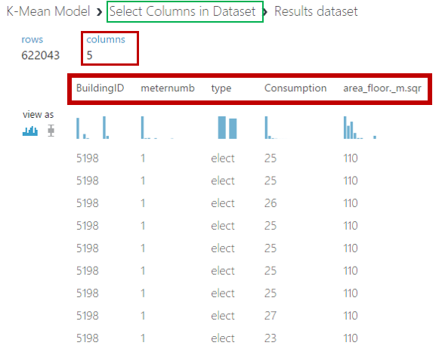 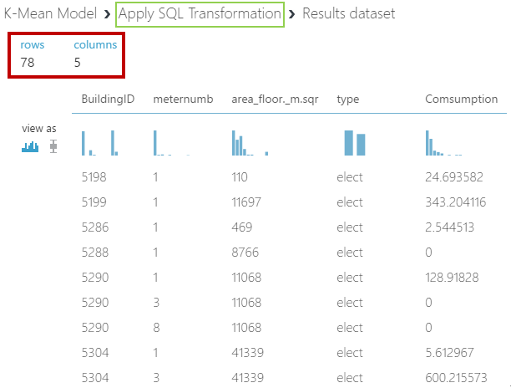

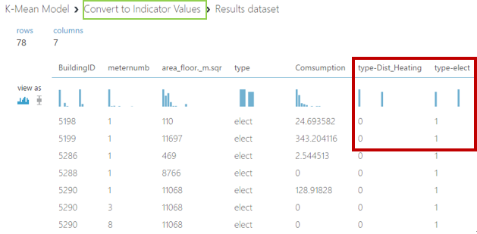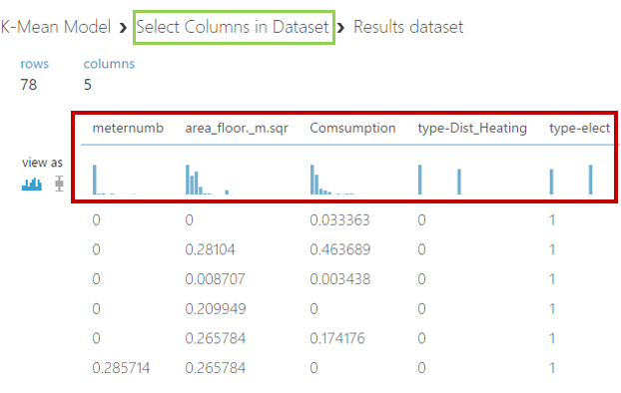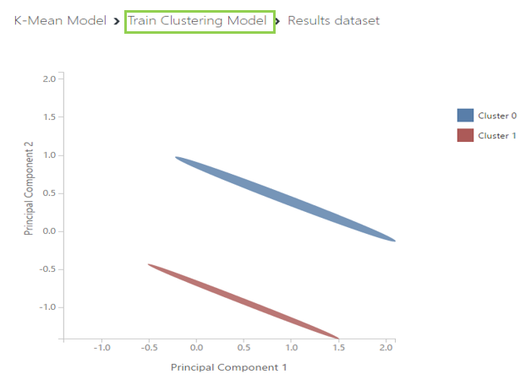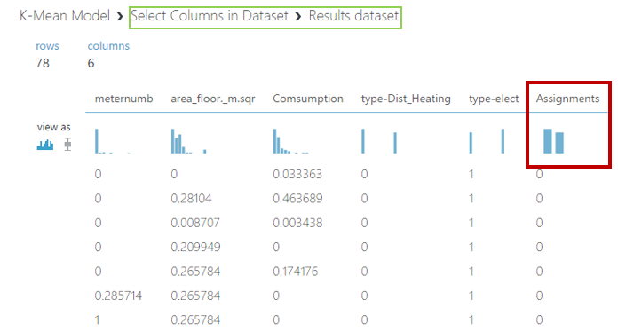

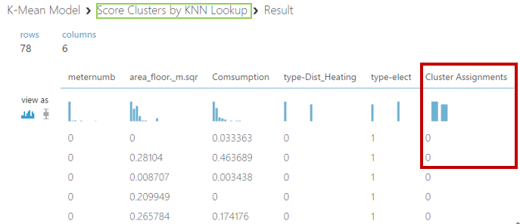

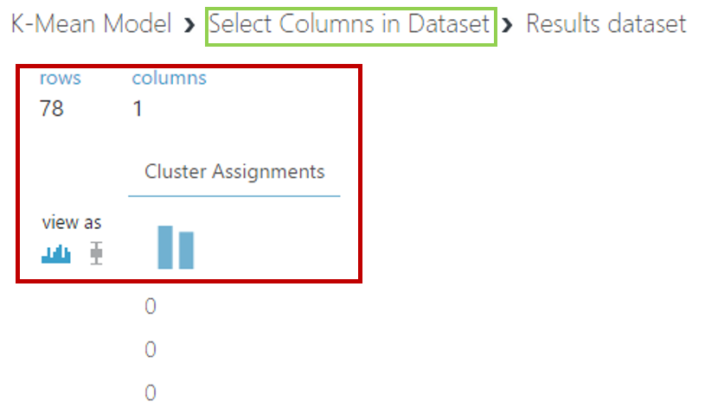

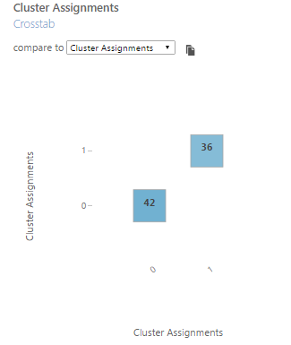

Steps (Hierarchical Clustering Model):

1. Upload the data.csv into Datasets of Azure Machine Learning Studio.
2. Input data from My Datasets
3. Select Columns from Dataset which are “meternumb”, “Consumption”, “area_floor._m.sqr”, “BuildingID”, “type”.
4. Using SQL code to Avg each column to make sure each column has same row.
5. Edit Metadata which change the type of column “type” to categorical.
6. Convert to indicator values about ‘type’ and make elect and dist_heating to 1 and 0; and then normalize data.
7. Select new columns for model use which are: “meternumb”, “area_floor._m.sqr”, “Comsumption”, “type-Dist_Heating”, “type-elect” without “type”.
8. Execute R Script to output Graphics.
9. Use Fit Hierarchical Cluster of Azure Machine Learning Studio to train the model, based on the algorithm, and get new column “Cluster Assignments”.
10. From train clustering model we can see two cluster which is 1 and 2.
11. Score the model in cluster by KNN lookup based on the algorithm.
12. Select “Cluster Assignments” and Evaluate the model.

**Hierarchical Clustering:** It is a method of [cluster analysis](https://en.wikipedia.org/wiki/Cluster_analysis), which seeks to build a [hierarchy](https://en.wikipedia.org/wiki/Hierarchy) of clusters. Hierarchical clustering only requires a measure of similarity between groups of data points.

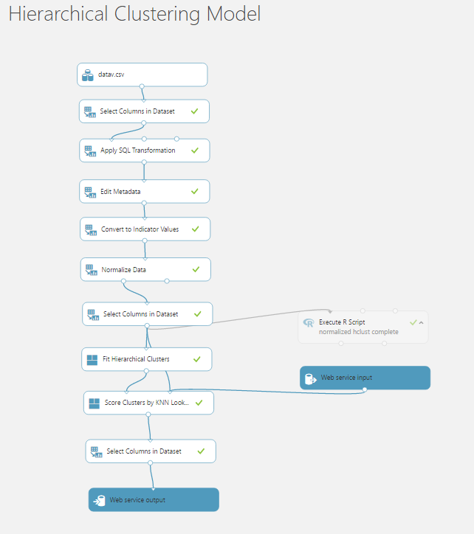 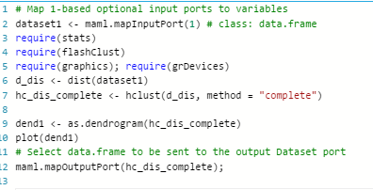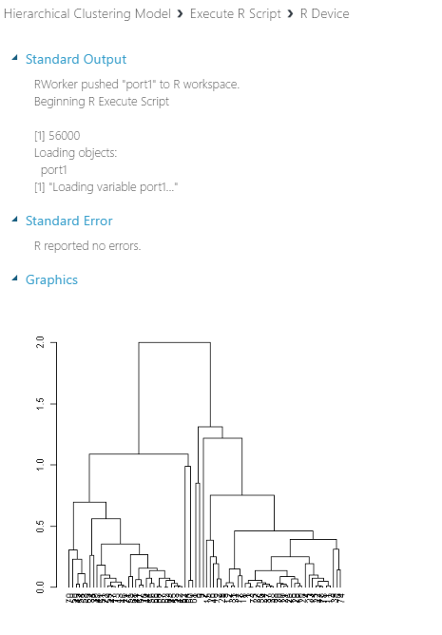 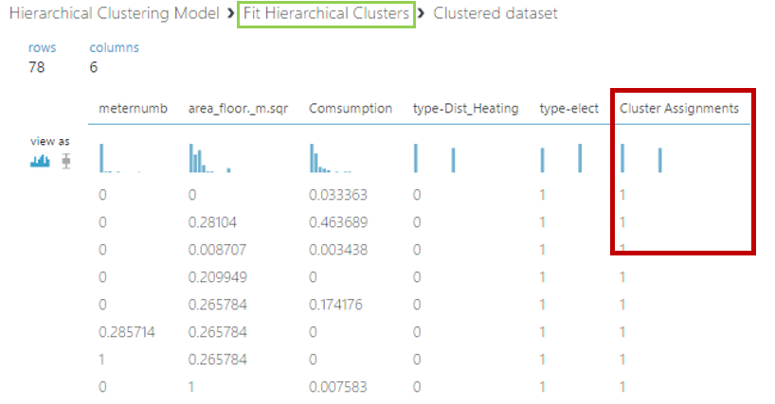

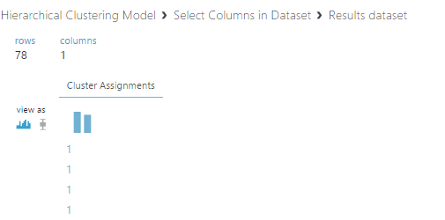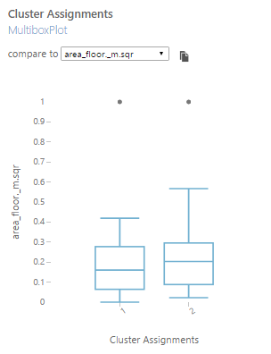

1. **Invoke Rest API:**

Tool used: Microsoft Visual Studio 2015

Language used: C#

Web technology used: asp.net, html, CSS

Prerequisite:

Services can be called with any programming language and from any device that satisfies three criteria:

* Has a network connection
* Has SSL capabilities to perform HTTPS requests
* Can parse JSON (by hand or support libraries)

Once the experiment has been deployed, there are four pieces of information that we need to call either the RRS or BES service.

* 1. The service **API key** or **Primary key**
  2. The service **request URI**
  3. The expected API **request headers** and **body**
  4. The expected API **response headers** and **body**

**How to Invoke Request Response Service**:

* 1. Create HttpClient object.
  2. Set-up the input message by copying the input-json body and replacing the input values with the values obtained from UI.
  3. Set the Authorization header based on the api key:

“Bearer” + apikey

* 1. Setup the client base address
  2. Call REST API and retrieve the response client using **‘await’**
  3. If the response is a success code, then store the result.
  4. If the response is an error code, then show the error.

**Deploy an ASP.NET web app to Azure App Service, using Visual Studio:**

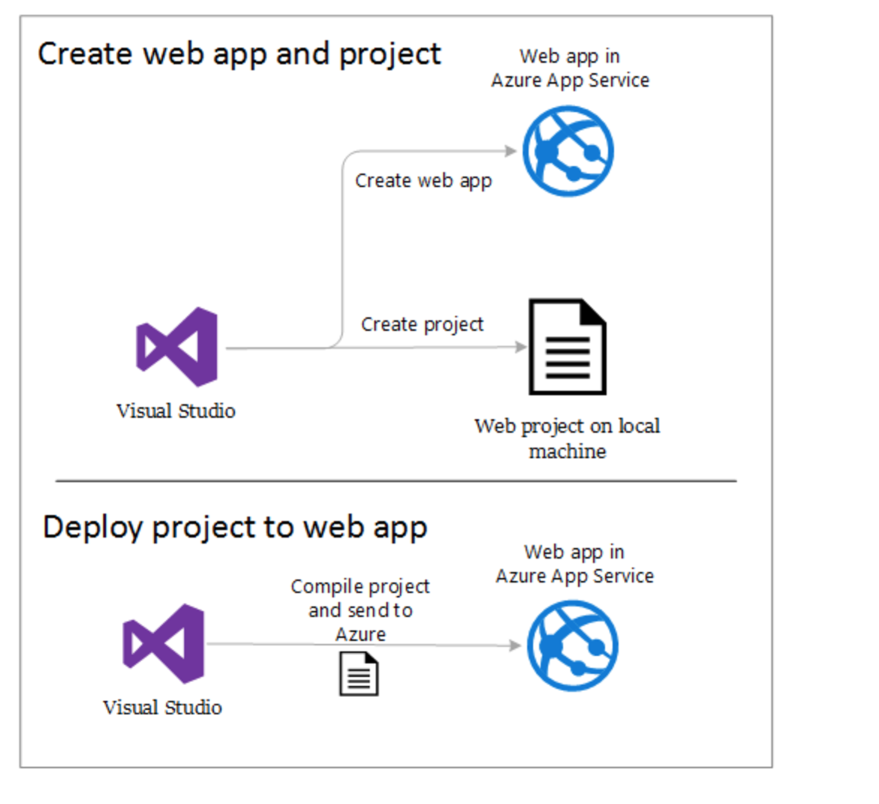

1. In the solution explorer, right click and choose Publish. In a few seconds, the Publish Web wizard appears.
2. On the Connection tab of the Publish Web wizard, click Next.
3. Next is the Settings tab. Here you can change the build configuration to deploy a debug build for [remote debugging](https://docs.microsoft.com/en-us/azure/app-service-web/web-sites-dotnet-troubleshoot-visual-studio#remotedebug).
4. The tab also offers several [File Publish Options](https://msdn.microsoft.com/library/dd465337.aspx#Anchor_2).
5. On the Settings tab, click Next.
6. On the Preview tab, click Publish. Upon successful deployment, the default browser automatically opens to the URL of the deployed web app